L.J INSTITUE OF COMPUTER APPLICATION



VOCO - Native Language Learning Platform

Developed By:

Krishna Radhani: 22002501210028
Meet Patel: 22002501210067
Yash Shah: 22002501210056

Under the Guidance of:

Prof. Harsh Shah

L.J SCHOOL OF COMPUTER APPLICATION
LJ Campus, LJ University Road, Off S.G. Road, Ahmedabad-382210

CERTIFICATE
Enrolment No: 22002501210028
This is to certify that Mr. Krishna Radhani of Integrated Master of Computer Applications (IMCA), Semester 8, Roll No B24, has satisfactorily completed his project titled VOCO under the supervision of Prof.Harsh Shah
Internal Guide Name | Head of Department
Prof. Harsh Shah | DR.Monica Gahalawat

SIGNATURE
Date of Submission:
DIRECTOR
Prof.Alok Manke

L.J SCHOOL OF COMPUTER APPLICATION

L.J SCHOOL OF COMPUTER APPLICATION
LJ Campus, LJ University Road, Off S.G. Road, Ahmedabad-382210

CERTIFICATE
Enrolment No: 22002501210067
This is to certify that Mr. Meet Patel of Integrated Master of Computer Applications (IMCA), Semester 8, Roll No B37, has satisfactorily completed his project titled VOCO under the supervision of Prof.Harsh Shah
Internal Guide Name | Head of Department
Prof. Harsh Shah | DR.Monica Gahalawat

SIGNATURE
Date of Submission:
DIRECTOR
Prof.Alok Manke

L.J SCHOOL OF COMPUTER APPLICATION

L.J SCHOOL OF COMPUTER APPLICATION
LJ Campus, LJ University Road, Off S.G. Road, Ahmedabad-382210

CERTIFICATE
Enrolment No: 22002501210056
This is to certify that Mr. Yash Shah of Integrated Master of Computer Applications (IMCA), Semester 8, Roll No B54, has satisfactorily completed his project titled VOCO under the supervision of Prof.Harsh Shah
Internal Guide Name | Head of Department
Prof.Harsh Shah | DR.Monica Gahalawat

SIGNATURE
Date of Submission:
DIRECTOR
Prof.Alok Manke

L.J SCHOOL OF COMPUTER APPLICATION

Sr.  No. | Table of Contents | Page  No.
1. | INTRODUCTION
 | 1.1 Existing System
 | 1.2 Need for the New System
 | 1.3 Objectives of the New System
 | 1.4 Problem Definition
 | 1.5 Core Components
 | 1.6 Project Profile
 | 1.7 Assumptions and Constraints
 | 1.8 Advantages and Limitations of the Proposed System
2. | REQUIREMENT DETERMINATION & ANALYSIS
 | 2.1 Requirement Determination
 | 2.2 Targeted Users
3. | SYSTEM DESIGN
 | 3.1 Use Case Diagram
 | 3.2 Class Diagram
 | 3.3 Interaction Diagram
 | 3.4 Activity Diagram
 | 3.5 Data Dictionary
4. | DEVELOPMENT
 | 4.1 Coding Standard
 | 4.2 Screenshots
5. | AGILE DOCUMENTATION
 | 5.1 Agile Project Charter
 | 5.2 Agile Roadmap/Schedule
 | 5.3 Agile Project Plan
 | 5.4 Agile User Story
 | 5.5 Agile Release Plan
 | 5.6 Agile Sprint Backlogs
 | 5.7 Agile Test Plan
6. | PROPOSED ENHANCEMENTS
7. | CONCLUSION
8. | BIBLIOGRAPHY

Introduction

The VOCO project is focused on developing an online language learning platform that responds to the growing need for accessible, effective, and engaging education. By offering a digital space where learners can practice reading and listening through interactive lessons and real-life conversations, VOCO aims to enhance language proficiency and learner confidence. The platform is designed not only for individuals seeking immediate learning support but also for those who wish to manage and improve their language skills on an ongoing basis, with easy access to expert-guided resources and structured learning paths.
VOCO is a transformative learning platform created to simplify and modernize the language learning experience. Through an intuitive and user-friendly application, VOCO enables users to register, personalize their learning journey, access lessons, and practice communication skills anytime and anywhere. This innovative approach removes traditional learning barriers and empowers users by giving them greater control over their learning pace, goals, and progress. By bringing multiple learning tools into a single platform, VOCO makes it easier for learners to manage their language development effectively.
The initiative is driven by the goal of improving access to quality language education through technology, addressing the increasing demand for flexible and online learning solutions. In today’s fast-paced world, where convenience and adaptability are essential, VOCO provides learners with a reliable platform to build and strengthen their native language skills. With expert guidance, interactive features, and practical learning experiences, VOCO empowers users to take an active role in their language journey and communicate with confidence in everyday life.

1.1 Existing System:-

Traditional language learning is primarily conducted through in-person and offline methods.
- Classroom-Based Learning: Learners attend physical language institutes or classrooms to enroll in language courses.
- Direct Interaction: Students interact face-to-face with instructors to learn grammar, vocabulary, pronunciation, and conversational skills.
- Printed Learning Materials: Books, worksheets, and printed exercises are commonly used to support learning.
- Practice Sessions: Learners practice speaking and listening through classroom activities, role-plays, and group discussions.
- Assessment Process: Tests and evaluations are conducted manually by instructors to assess learner progress.

1.2 Need for the New System:-

- Rising Costs of Traditional Learning: Conventional language learning methods such as classroom courses and private tutoring are becoming increasingly expensive, creating a need for a more affordable learning solution.
- Changing Learning Landscape: The rapid growth of digital education platforms has increased competition and user expectations, highlighting the need for a modern, technology-driven language learning approach.
- Affordable Learning Options: The new system aims to provide cost-effective language learning opportunities without compromising the quality of education.
- Wider Learning Resources: An online language learning app can offer a wide range of lessons, exercises, and practice modules tailored to different proficiency levels and learning styles.
- Convenient Access: Learners can access language lessons anytime and anywhere, eliminating the need for physical attendance.
- Detailed Learning Content: The app will provide comprehensive explanations, audio pronunciations, interactive exercises, and cultural context to help learners understand and use the language effectively.
- Easy Enrollment and Progress Tracking: Users can easily register, select learning paths, and track their progress through automated assessments and performance reports.
- Enhanced Learner Satisfaction: Improved accessibility, flexibility, and affordability will lead to higher learner engagement and satisfaction.
- Market Relevance: Implementing this system will help position the native language learning app as a modern, user-friendly, and competitive solution in the evolving digital education market.

1.3 Objective of the New System:-

- To develop a user-friendly native language learning application that is accessible anytime and anywhere.
- To provide affordable and high-quality language learning resources for users of all age groups.
- To promote effective learning through interactive lessons, audio-visual content, and practice exercises.
- To support learners at different proficiency levels, from beginners to advanced users.
- To enable personalized learning paths based on user performance and progress.
- To automate assessments and provide instant feedback to enhance learning efficiency.
- To track learner progress and generate performance reports for continuous improvement.
- To preserve and promote native languages by making learning engaging and widely accessible.

1.4 Problem Definition:-

Traditional native language learning methods rely heavily on classroom-based instruction, physical learning materials, and fixed schedules. These methods are often expensive, time-consuming, and inaccessible to many learners due to geographical, financial, or time constraints. Additionally, learners receive limited personalized attention, delayed feedback, and fewer opportunities for consistent practice outside the classroom. This creates a need for a modern, digital solution that provides affordable, accessible, interactive, and effective native language learning experiences.

1.5 Core Components:-
- User Registration and Profile Management: Allows users to create accounts, manage personal details, select preferred native language, and set learning goals.
- Learning Modules: Structured lessons covering alphabets, vocabulary, grammar, sentence formation, and conversational usage.
- Audio and Pronunciation Support: Native speaker audio clips and pronunciation guides to help learners improve speaking and listening skills.
- Interactive Exercises: Quizzes, fill-in-the-blanks, matching activities, and listening practice to reinforce learning.
- Progress Tracking System: Monitors learner performance, completed lessons, scores, and improvement over time.
- Assessment and Feedback Module: Automated tests with instant feedback to help learners identify strengths and areas for improvement.
- Personalized Learning Path: Adapts lesson difficulty and content based on user progress and learning speed.
- Admin and Content Management System: Allows administrators to manage users, upload learning content, update lessons, and monitor app performance.

1.6 Project Profile:-
Project Title | VOCO
Type of Application | Web Application
Duration | 6 Months
Team Size | 3 People
Front End | HTML, CSS, JavaScript, ReactJs
Back End | NodeJs,ExpressJs
Database | MongoDB
Tools Used | VS Code
Project Internal Guide | Prof. Harsh Shah

1.7 Assumptions and Constraints:-

Assumptions
- Users have access to a smartphone, tablet, or computer capable of running the application.
- Users possess basic digital literacy to navigate the app and use its features.
- Internet connectivity is available for initial registration, content updates, and online features.
- Learners are motivated to practice regularly for effective language acquisition.
- Audio and visual resources provided in the app accurately represent native language usage.
- The system will be used by learners of varying age groups and proficiency levels.

Constraints
- Limited internet connectivity may restrict access to online features and real-time updates.
- Device compatibility issues may arise across different operating systems and screen sizes.
- Development time and budget limitations may affect the number of features implemented.
- Data privacy and security

1.8 Advantages and Limitations of Proposed System:-

1. Advantages :-

Provides anytime and anywhere access to native language learning.

More cost-effective compared to traditional classroom-based learning.

Supports self-paced learning, allowing users to learn at their own convenience.

Improves pronunciation and listening skills through native speaker audio support.

Interactive exercises and instant feedback enhance learner engagement.

Personalized learning paths based on user progress and performance.

Progress tracking helps learners monitor improvement over time.

Helps preserve and promote native languages through digital platforms.

2. Limitations:-

Requires a smartphone or internet-enabled device for access.

Limited effectiveness without regular practice and learner motivation.

Lack of face-to-face interaction may affect learners who prefer classroom learning.

Dependence on internet connectivity for updates and online features.

Initial development and content creation require significant time and resources.

2. Requirement Determination and Analysis.

2.1 Requirement Determination:-

Functional Requirements:-

Hardware Requirement:
- Intel(R) Core (TM) i5-6040U CPU@ 2.3GHz
- 4GB Ram
- Hard Disk 500GB(SSD)

Software Requirement:
- Operating System: Windows 04
- Database: SQLite
- Development Tool: Visual Studio Code

Non-Functional Requirements:-

- Performance and Scalability: Ensuring fast load times and the ability to scale during peak usage times enhances user satisfaction and prevents potential loss of customers.
- Security: Protecting user data and ensuring secure transactions is critical for maintaining user trust and complying with data protection regulations.
- Usability and Accessibility: A user-friendly and accessible design improves the overall user experience, making it easier for all users to use the service.
- Data Backup and Recovery: Ensuring data integrity and availability for maintaining business continuity and user trust.

2.2 Targeted Users:-

- Students: School and college students who want to learn or improve their native language skills for academic purposes.
- Beginners: Individuals with little or no prior knowledge of the native language.
- Working Professionals: Users seeking flexible and self-paced language learning alongside their work schedules.
- Language Enthusiasts: People interested in learning native languages for cultural, personal, or travel reasons.
- Educators and Institutions: Teachers and educational organizations using the app as a supplementary learning tool.

System Design.

3.1 Use Case Diagram:-
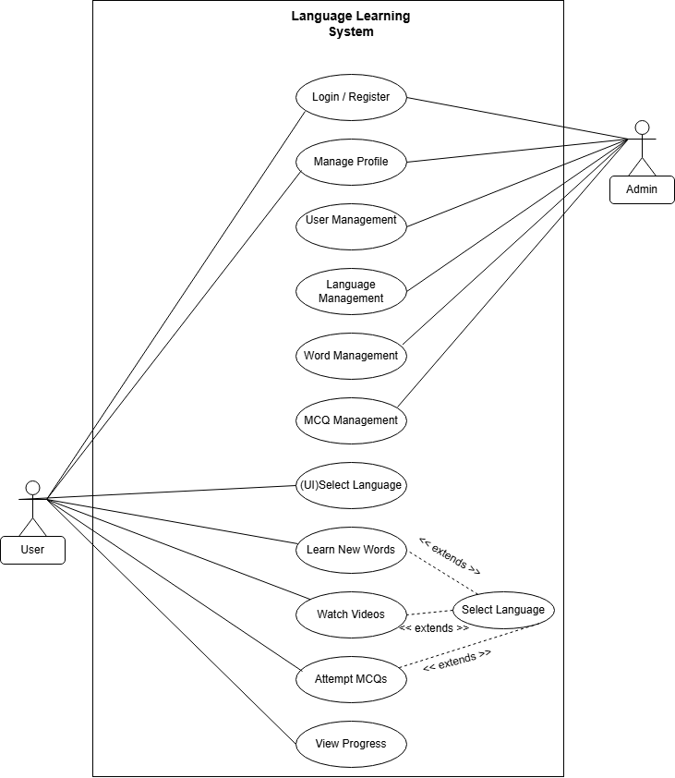

3.2 Class Diagram:-

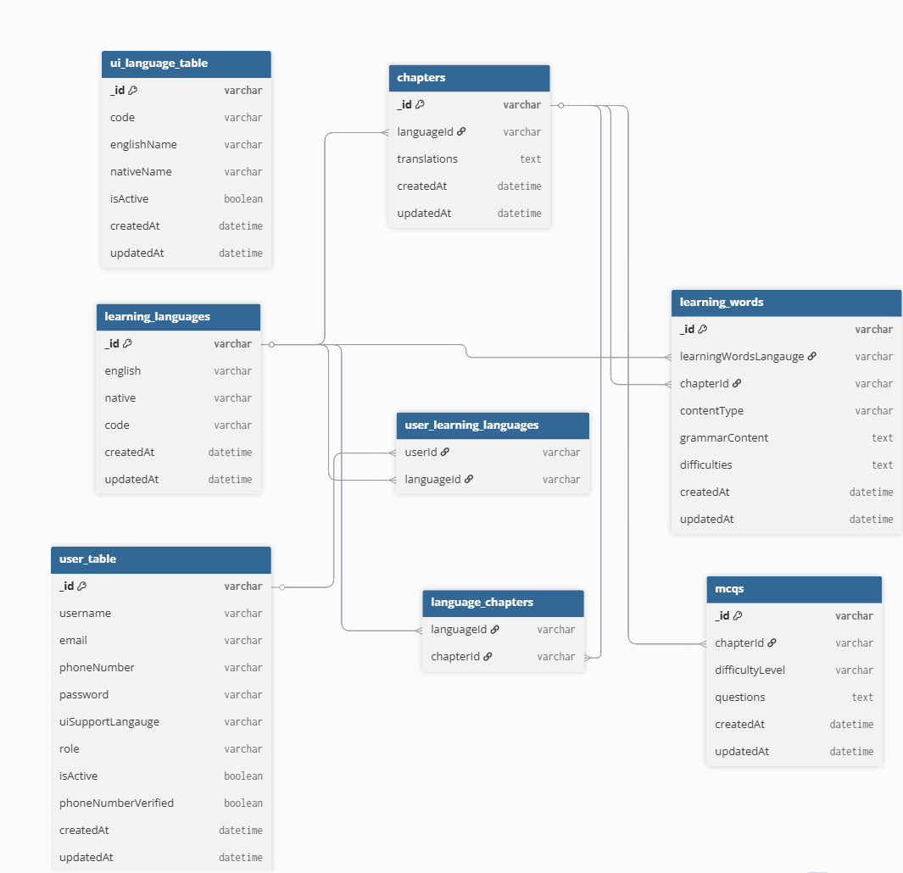

3.3 Interaction Diagram:-

- Interaction Diagram for User Register and Login :-
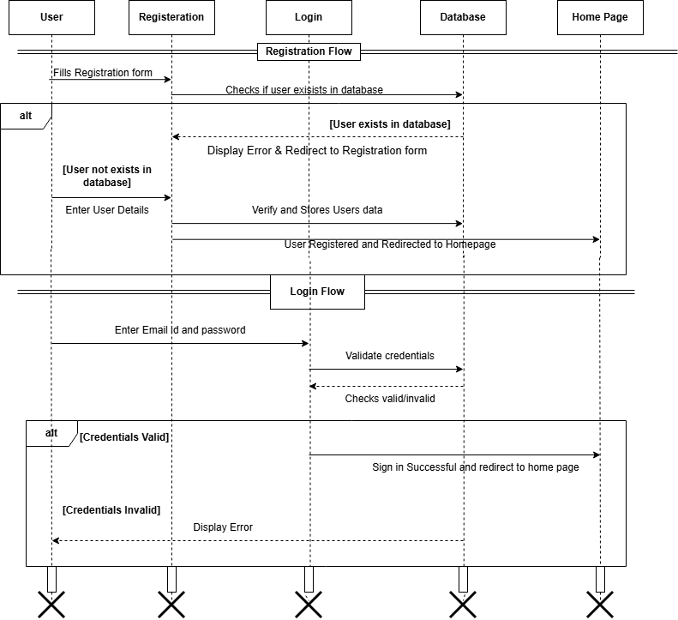

- Interaction Diagram for Learning a Language:-
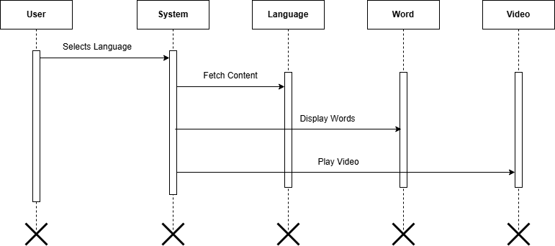

- Interaction Diagram for Admin Interaction:-

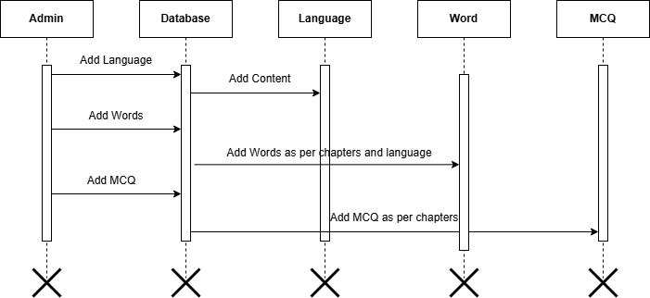

Activity Diagram:-

      - Activity Diagram for User :-
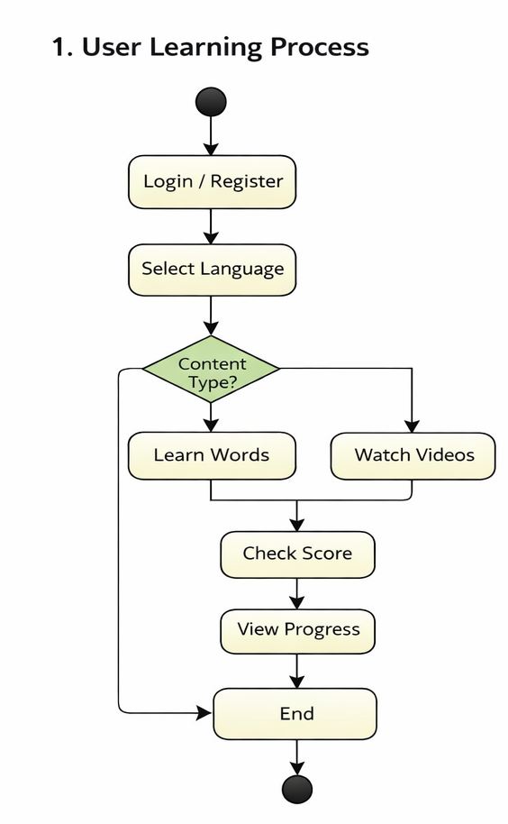

      - Activity Diagram for Admin :-
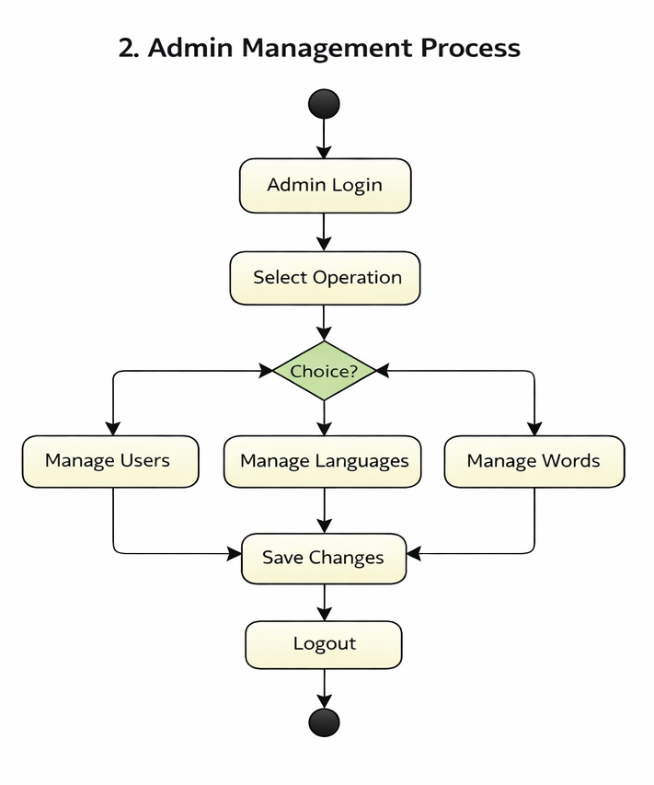

3. Activity Diagram for MCQ:-
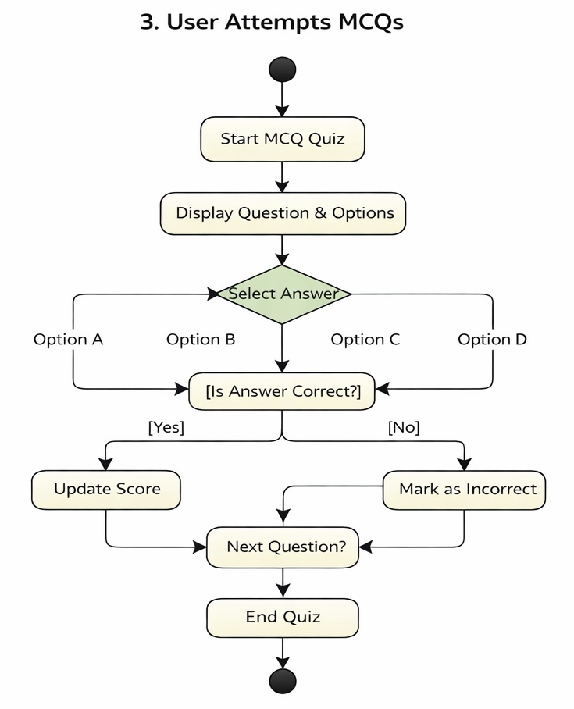

3.5 Data Dictionary:-

Total Number of Tables Required:- 6
Sr.No | Table Name | Table Description
1 | user_tables | Stores user account information. Each document contains user details such as username, email, password, role, and learning preferences.
2 | learning_languages | Stores information about available learning languages and their associated chapters.
3 | chapters | Stores chapters for each language with multilingual titles.
4 | learningwords | Stores vocabulary and grammar content for each chapter with difficulty levels.
5 | MCQ | Stores multiple-choice questions for chapter-based and final exams.
6 | ExamAttempt | Stores user exam attempts for both chapter and final exams.
7 | ui_language_tables | Stores UI language translations used in the application interface.  Each document contains text labels for different languages used in the frontend.
8 | UserProgress | Tracks user learning progress, completed chapters, and course completion status.

- Table Name: - user_tables
Table Description: - Stores user account information. Each document contains user details such as username, email, password, role, and learning preferences.
Field Name | Data Type | Constraint | Description
_id | ObjectId | Primary Key | Unique identifier for each user
username | String | Required | Username
email | String | Required, Unique | User email
phoneNumber | String | Required, Unique | Phone number
password | String | Required | User password
uiSupportLangauge | String | Default: English | UI language preference
learningLanguages | ObjectId[] | Ref: learning_languages | Selected learning languages
role | String | Default: user | User role (user/admin)
isActive | Boolean | Default: true | Active or inactive user
phoneNumberVerified | Boolean | Default: false | Phone verification status
createdAt | Date | Auto | Record creation time
updatedAt | Date | Auto | Record update time

- Table Name: - learning_languages
Table Description: - Stores information about available learning languages and their associated chapters.
Field Name | Data Type | Constraint | Description
_id | ObjectId | Primary Key | Unique identifier
english | String | Required | Language name in English
native | String | Required | Language name in native form
code | String | Required | Language code (e.g., en, hi)
chapters | ObjectId[] | Ref: chapters | Related chapters
createdAt | Date | Auto | Creation time

- Table Name: - chapters
Table Description: - Stores chapters for each language with multilingual titles.
Field Name | Data Type | Constraint | Description
_id | ObjectId | Primary Key | Unique identifier
languageId | ObjectId | Ref: learning_languages, Required | Related language
translations | Map<String> | - | Chapter names in multiple languages
createdAt | Date | Auto | Creation time
updatedAt | Date | Auto | Update time

- Table Name: - LearningWords
Table Description: - Stores vocabulary and grammar content for each chapter with difficulty levels.
Field Name | Data Type | Constraint | Description
_id | ObjectId | Primary Key | Unique identifier
learningWordsLangauge | ObjectId | Ref: learning_languages, Required | Language reference
chapterId | ObjectId | Ref: chapters, Required | Chapter reference
contentType | String | Required | Type (word/grammar)
grammarContent | Map<String> | Default {} | Multi-language grammar content
difficulties | Array | Required | Difficulty levels
difficulties.level | String | Required | Difficulty level
difficulties.words | Map[] | Required | Words data
createdAt | Date | Auto | Creation time
updatedAt | Date | Auto | Update time

- Table Name: - MCQs
Table Description: - Stores multiple-choice questions for chapter-based and final exams.
Field Name | Data Type | Constraint | Description
_id | ObjectId | Primary Key | Unique identifier
chapterIds | ObjectId[] | Ref: chapters, Required | Related chapters
difficultyLevel | String | Required | Difficulty level
questions | Array | Required | List of questions
questions.question | Map | Required | Question in multiple languages
questions.options | Map[] | Required | Options list
questions.correctAnswer | Number | Required | Correct option index
createdAt | Date | Auto | Creation time
updatedAt | Date | Auto | Update time

- Table Name: - ExamAttempt
Table Description: - Stores user exam attempts for both chapter and final exams.
Field Name | Data Type | Constraint | Description
_id | ObjectId | Primary Key | Unique identifier
userId | ObjectId | Required | User reference
chapterId | ObjectId | Optional | Chapter exam reference
langId | ObjectId | Optional | Final exam language reference
examType | String | Required | Type (chapter/final)
mcqIds | ObjectId[] | Ref: MCQs | MCQ references
answers | Array | - | User answers
answers.mcqId | ObjectId | - | MCQ reference
answers.questionIndex | Number | - | Question index
answers.selectedOption | Number | - | Selected option
startTime | Date | - | Exam start time
endTime | Date | - | Exam end time
isCompleted | Boolean | Default false | Completion status
createdAt | Date | Auto | Creation time
updatedAt | Date | Auto | Update time

- Table Name: - ui_language_table
Table Description: - Stores supported UI languages for the platform.
Field Name | Data Type | Constraint | Description
_id | ObjectId | Primary Key | Unique identifier
code | String | Unique | Language code
englishName | String | - | Language name in English
nativeName | String | - | Language name in native
isActive | Boolean | Default true | Active status
createdAt | Date | Auto | Creation time
updatedAt | Date | Auto | Update time

- Table Name: - UserProgress
Table Description: - Tracks user learning progress, completed chapters, and course completion status.
Field Name | Data Type | Constraint | Description
_id | ObjectId | Primary Key | Unique identifier
userId | ObjectId | Ref: user_table, Unique | User reference
learningLanguages | Array | Required | Language progress
learningLanguages.languageId | ObjectId | Ref: learning_languages | Language reference
learningLanguages.completedChapters | ObjectId[] | Ref: chapters | Completed chapters
learningLanguages.isCourseCompleted | Boolean | Default false | Completion status
learningLanguages.completedAt | Date | Default null | Completion date
createdAt | Date | Auto | Creation time
updatedAt | Date | Auto | Update time

4. Development.

While working on VOCO, the three-person team, which included Krishna, Meet, and Yash divided the work equally to ensure a smooth and effective workflow.

Team Member Responsibilities:-
Meet took care of the data gathering and back-end coding. He utilized SQL Server Management Studio (SSMS) to gather, organize, and save healthcare-related information securely. He also coded the back-end on .Net and integrated the database with the site to facilitate the seamless transfer of information.

Yash was responsible for developing the website. Using HTML, CSS, JavaScript, and Bootstrap, he created

the front-end interface, thus making it user-friendly and visually appealing. He focused on the integration of features such as telemedicine consultations, scheduling appointments, and e-prescribing functionality.

Krishna maintained documentation and ensured quality. He created detailed documentation of the projects, such as technical specifications, user manuals, and so forth. His tasks ensured that aspects of the projects were well-recorded for current and future referrals and utilization. Additionally, he was actively engaged in creating tests protocols to improve quality standards.

The group had frequent synchronization sessions to coordinate progress on each activity. Integration required iterative testing to ensure compatibility of the front-end, back-end, and database modules. Effective collaboration and free communication among us facilitated Health Connect as a seamless digital healthcare solution.

4.1 Coding Standard:-

For the development of our project, we followed clear and simple coding standards to keep the code organized, readable, and easy to maintain. We used consistent naming conventions with all variables, functions, class names, and constants written in lowercase for simplicity and uniformity. Underscores were used where needed to improve readability.

Proper indentation and spacing were maintained throughout the code, and comments were added where needed to explain complex logic.

Additionally, if the project needs to be shared with teammates, it can be done easily by migrating only the necessary data files. This minimizes effort and ensures smooth setup and consistency across different environments.

Screenshots:-

- Home Page

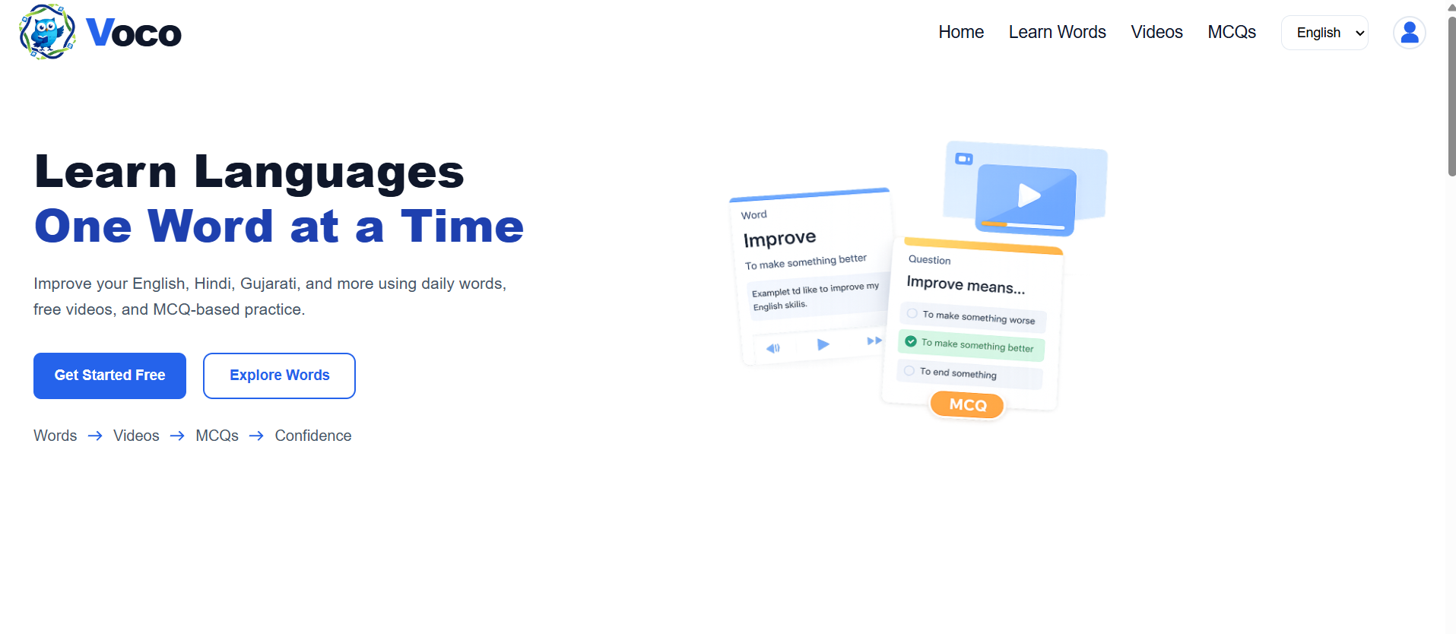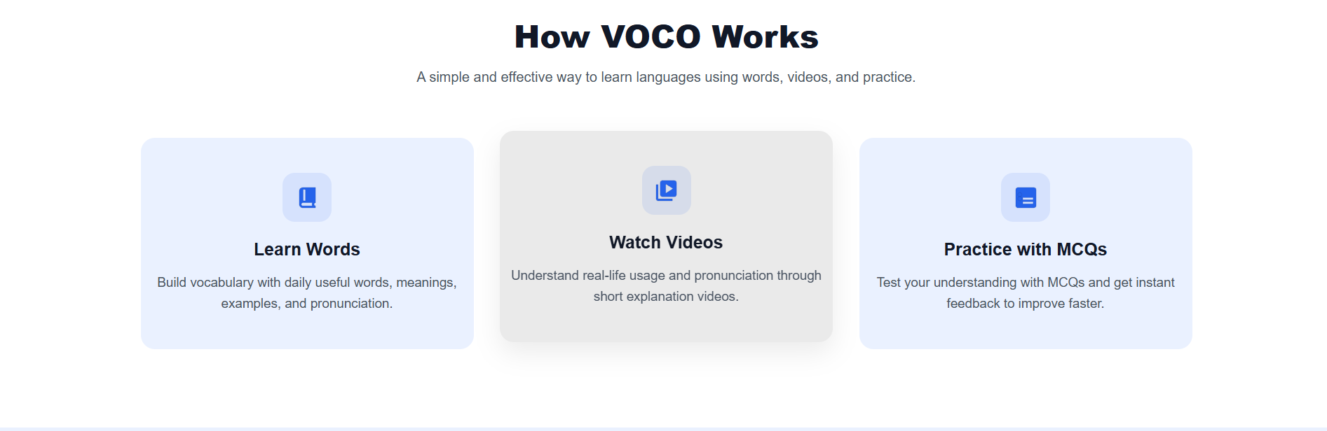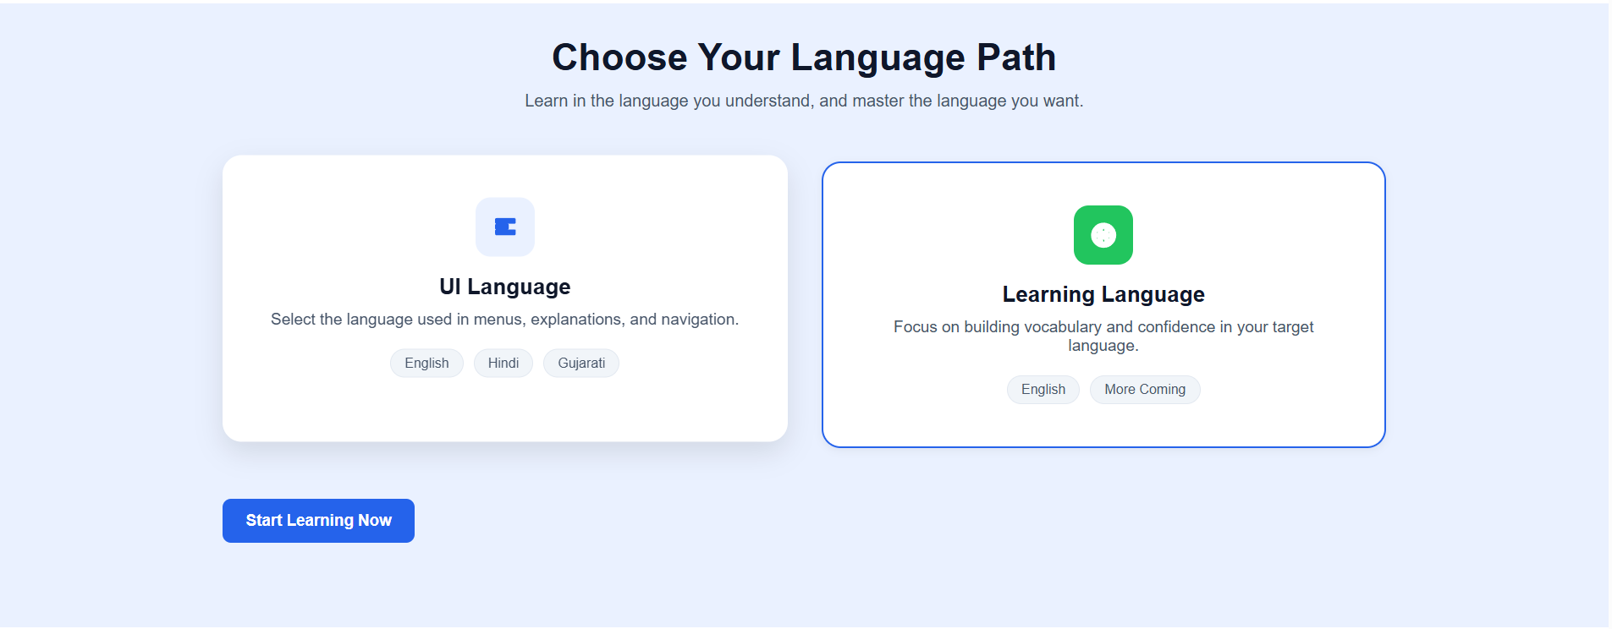
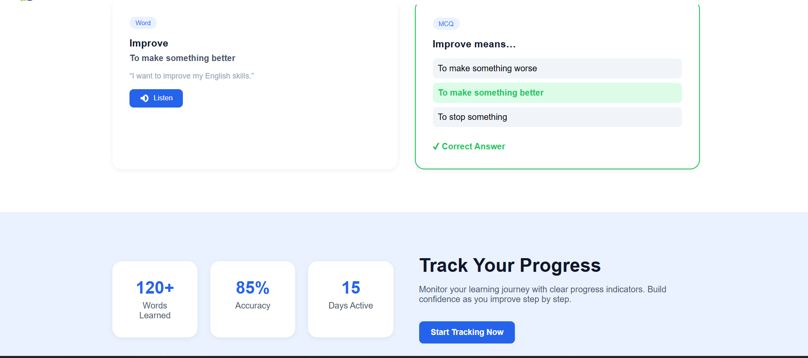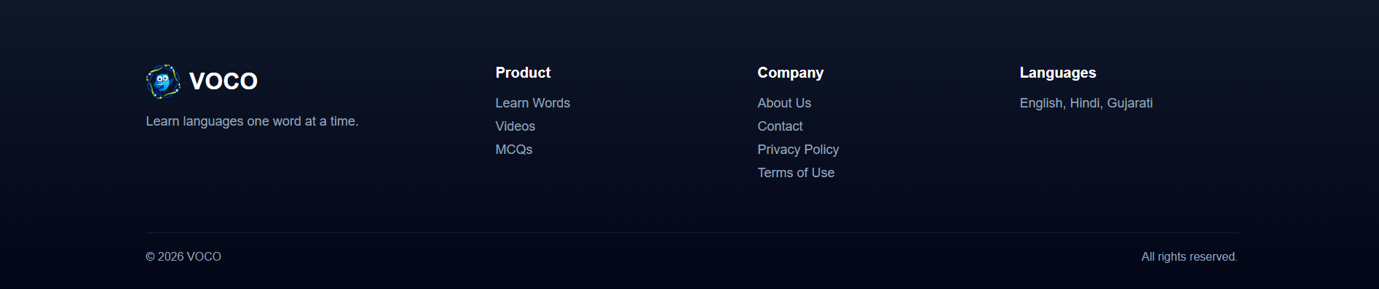

- SignIn
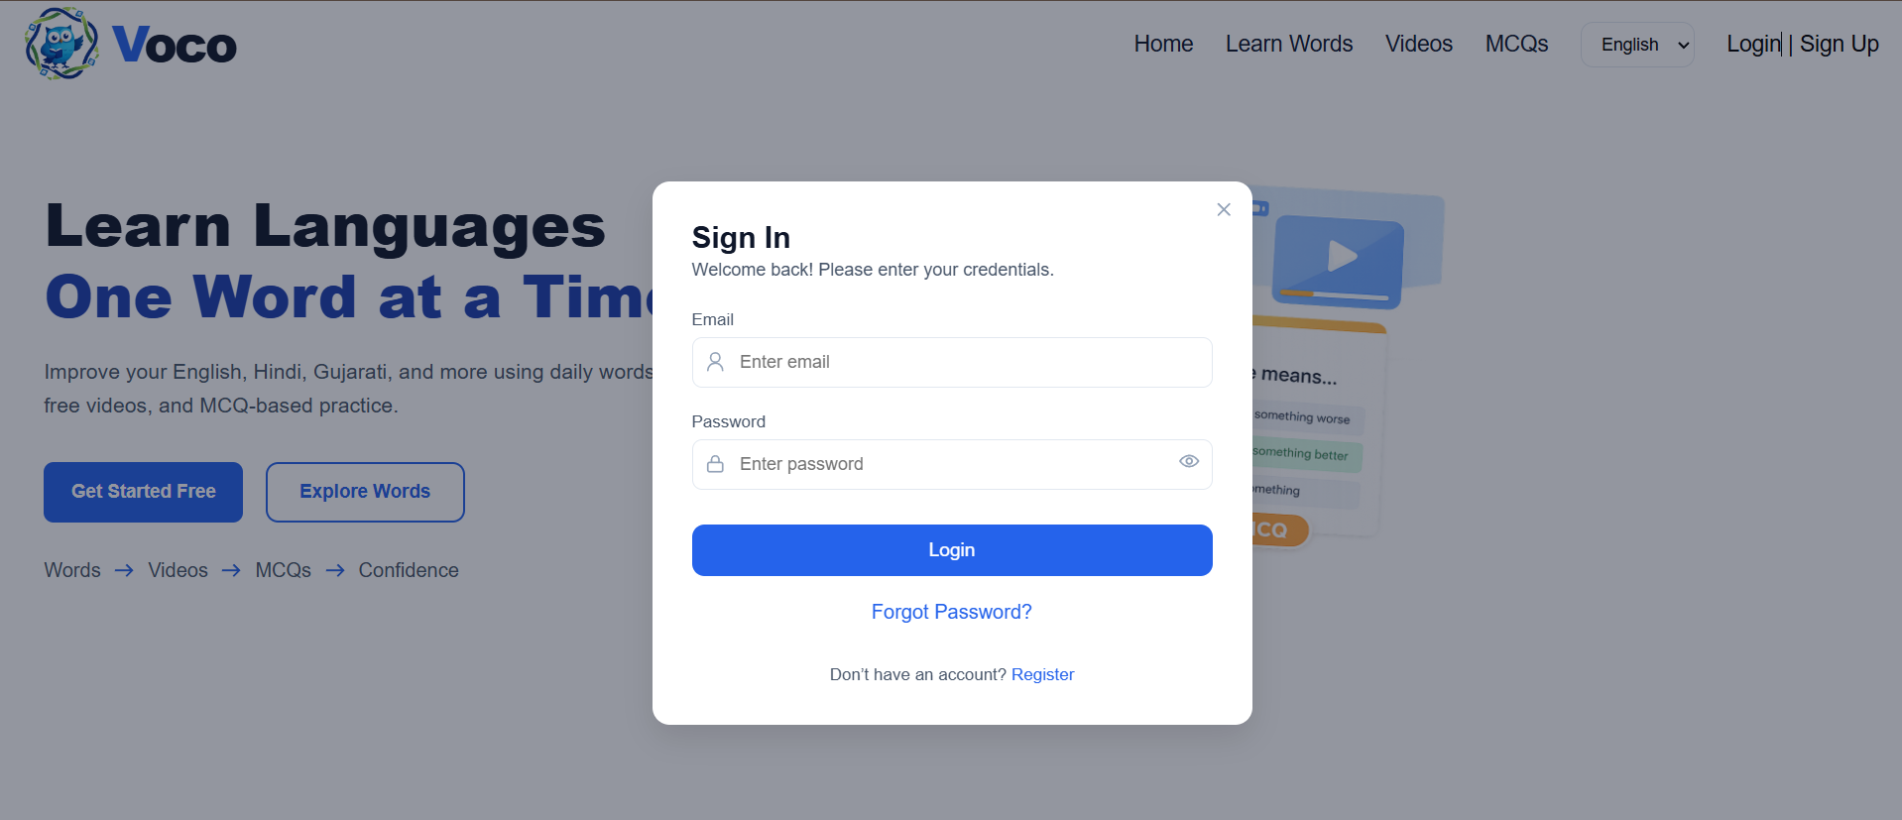
- SignUp

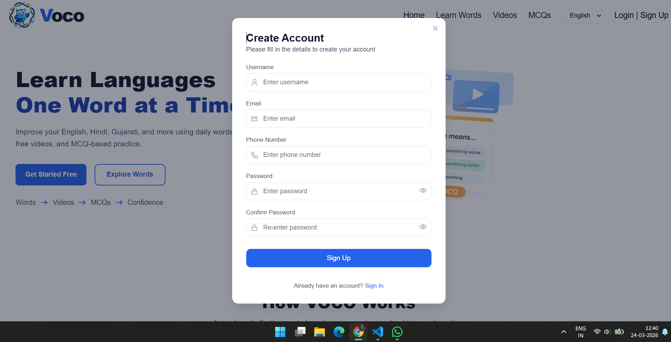
- OTP Verify Page

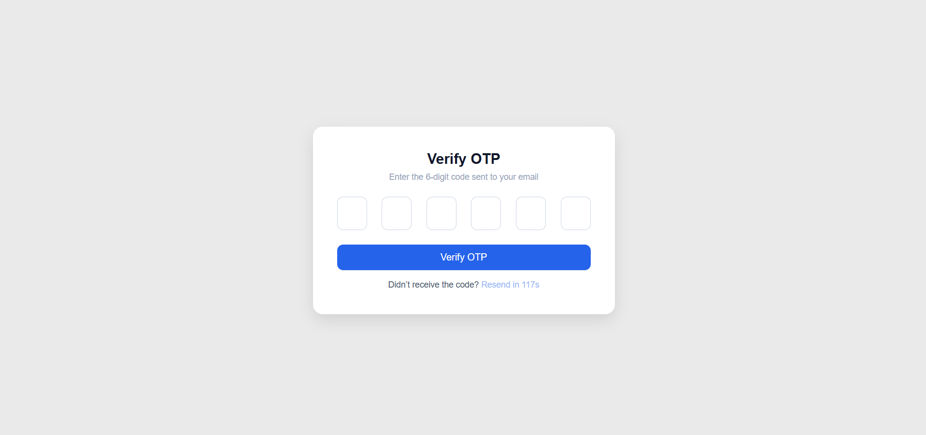

- Learn Words Page
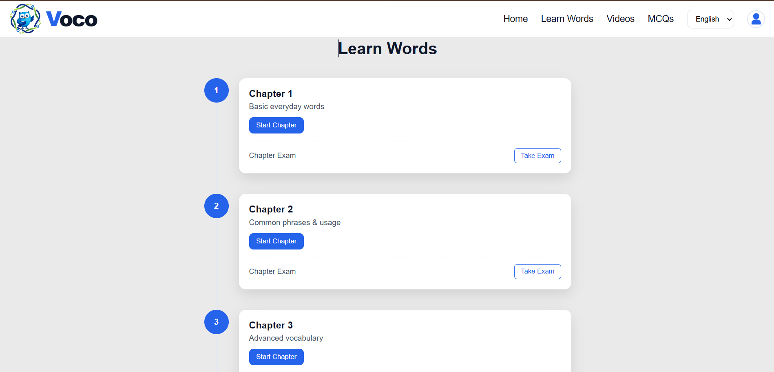

- Videos Page
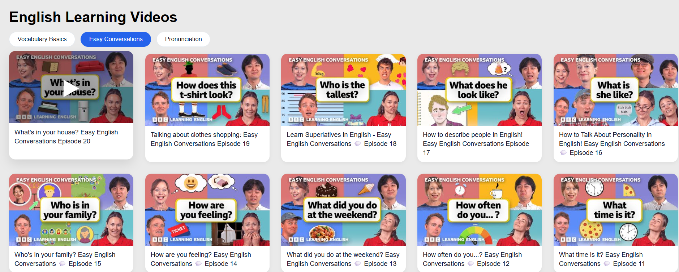

- MCQs Page
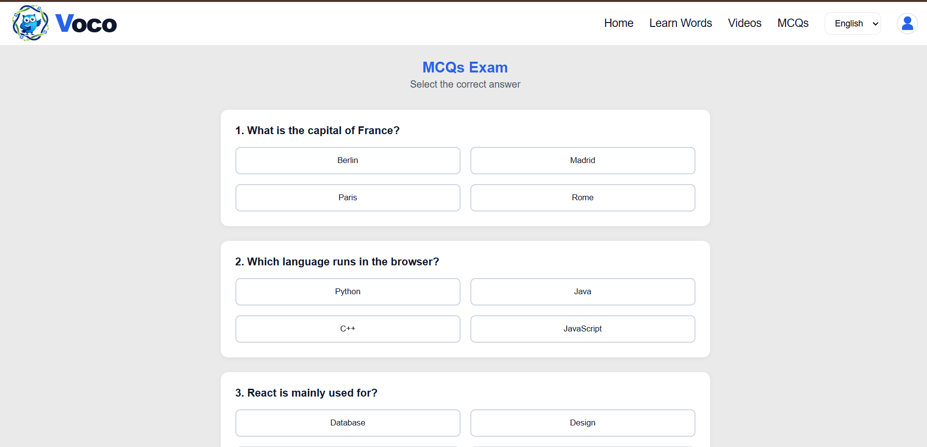
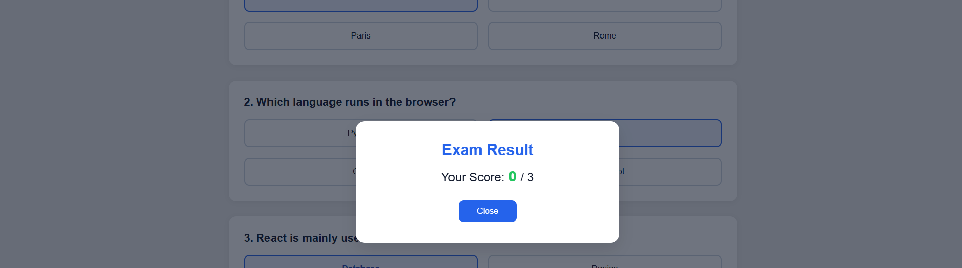

- Dasabord Page
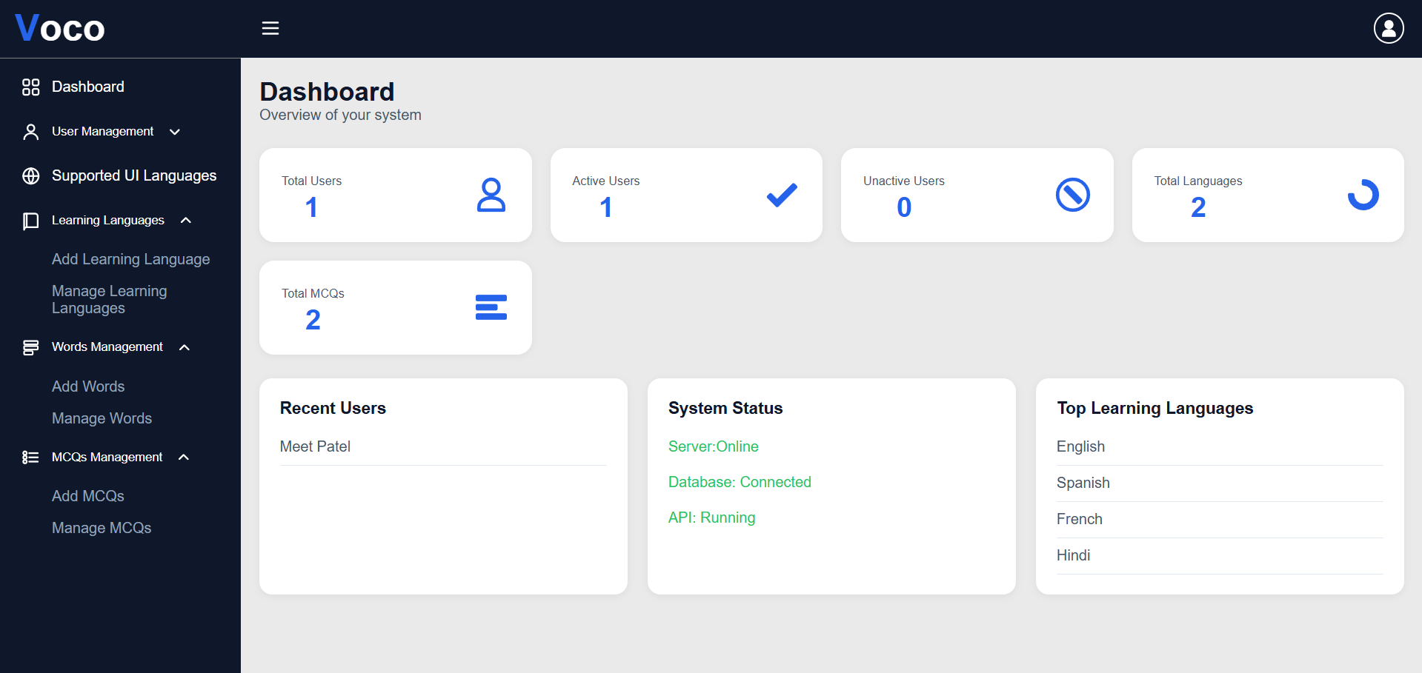

- Supported langauge
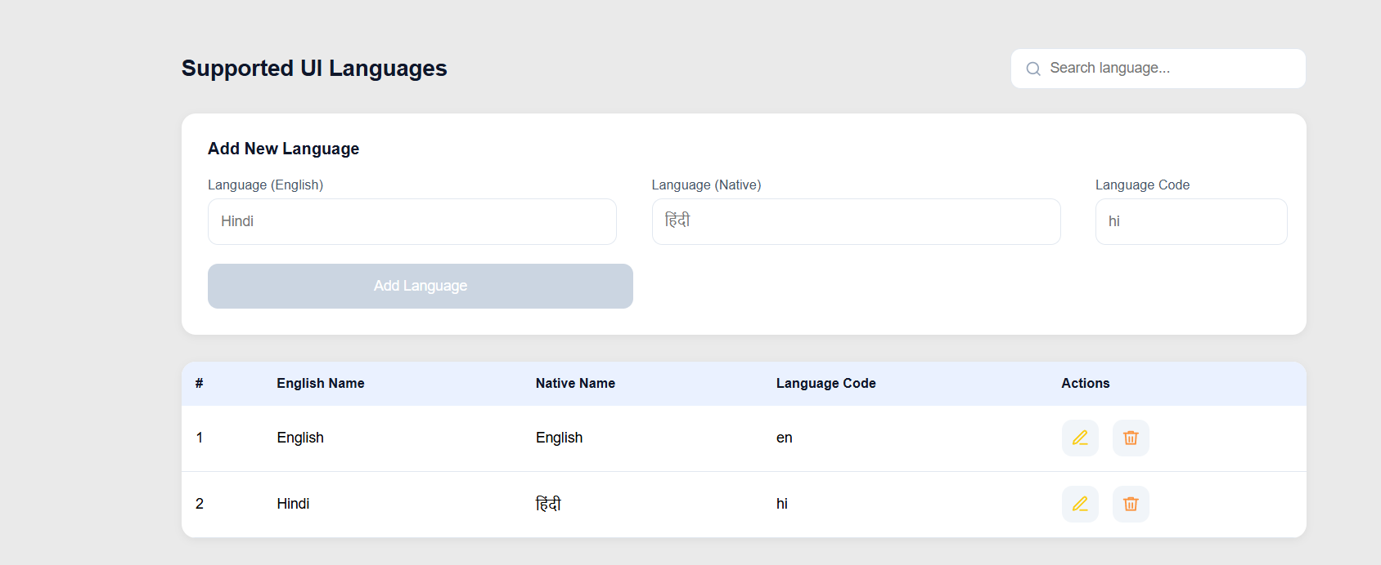
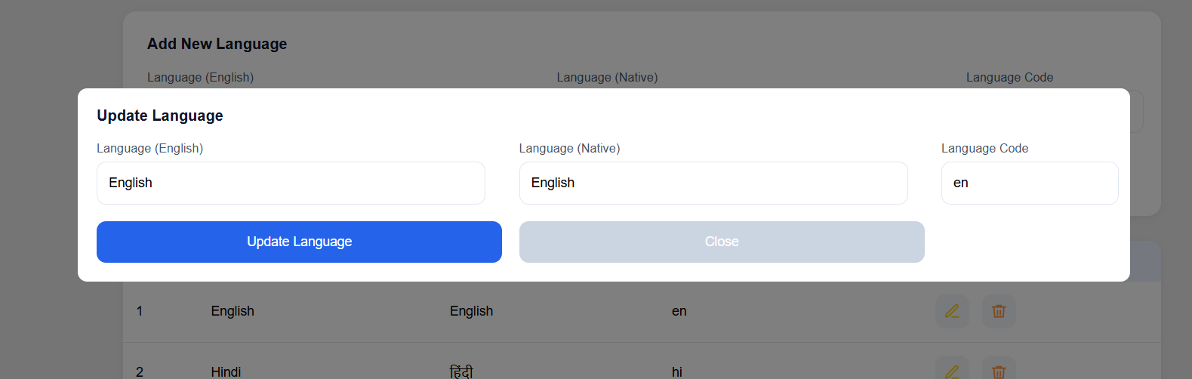

- Add New Learning Language page
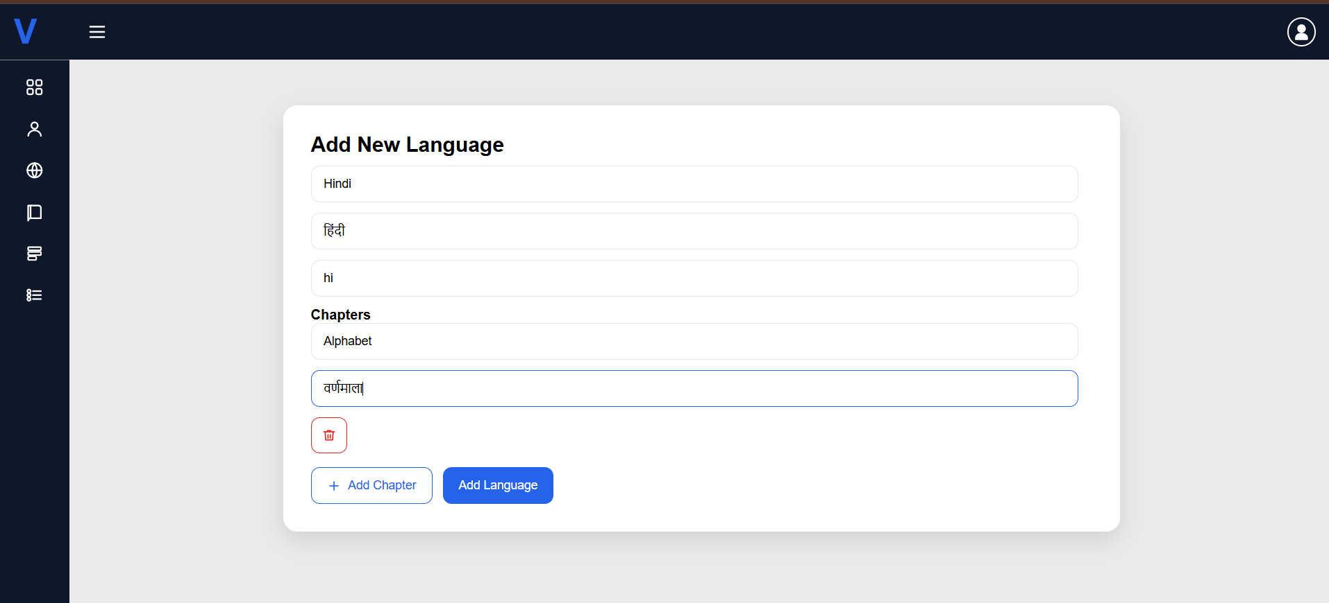

- View All Learning Language Page
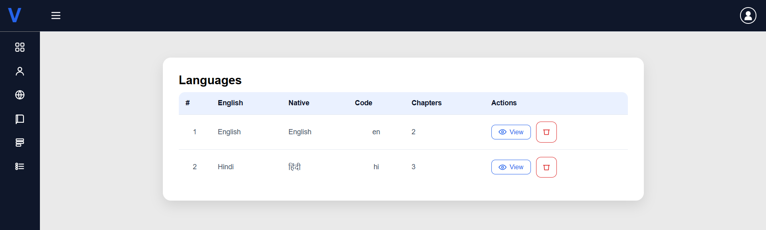

- View All Chapters from Learning Language Page
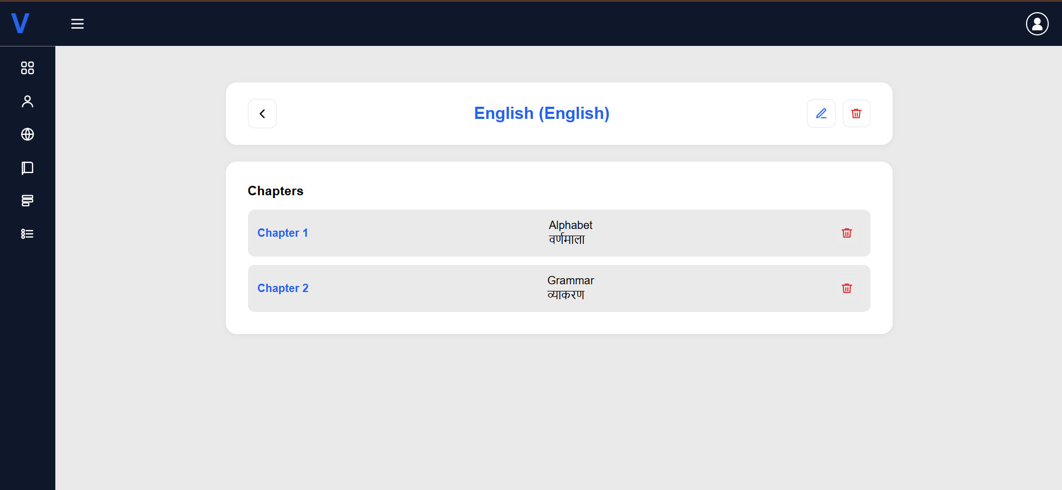

- Update Learning Language Page
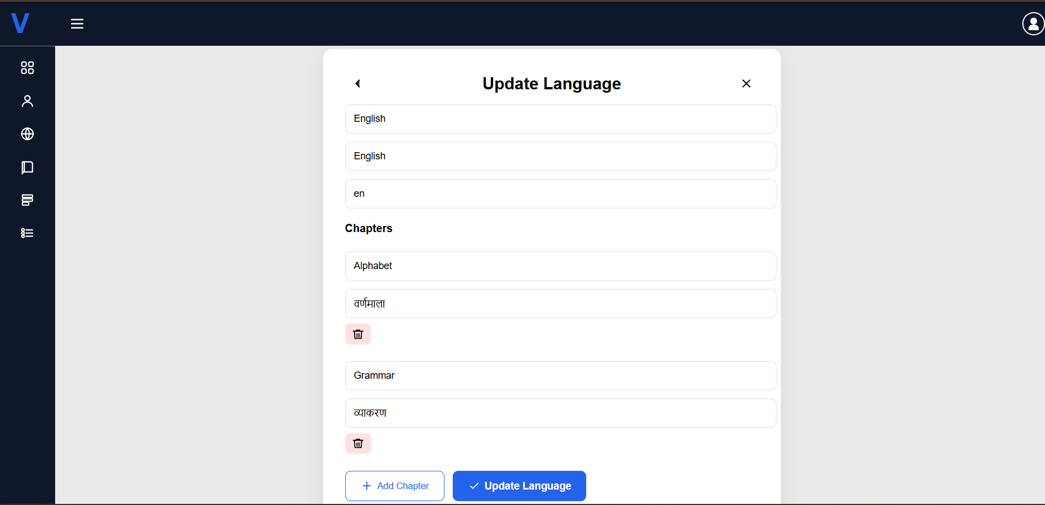

- Add Learning Words Page
if admin select the Content Type = Text Block
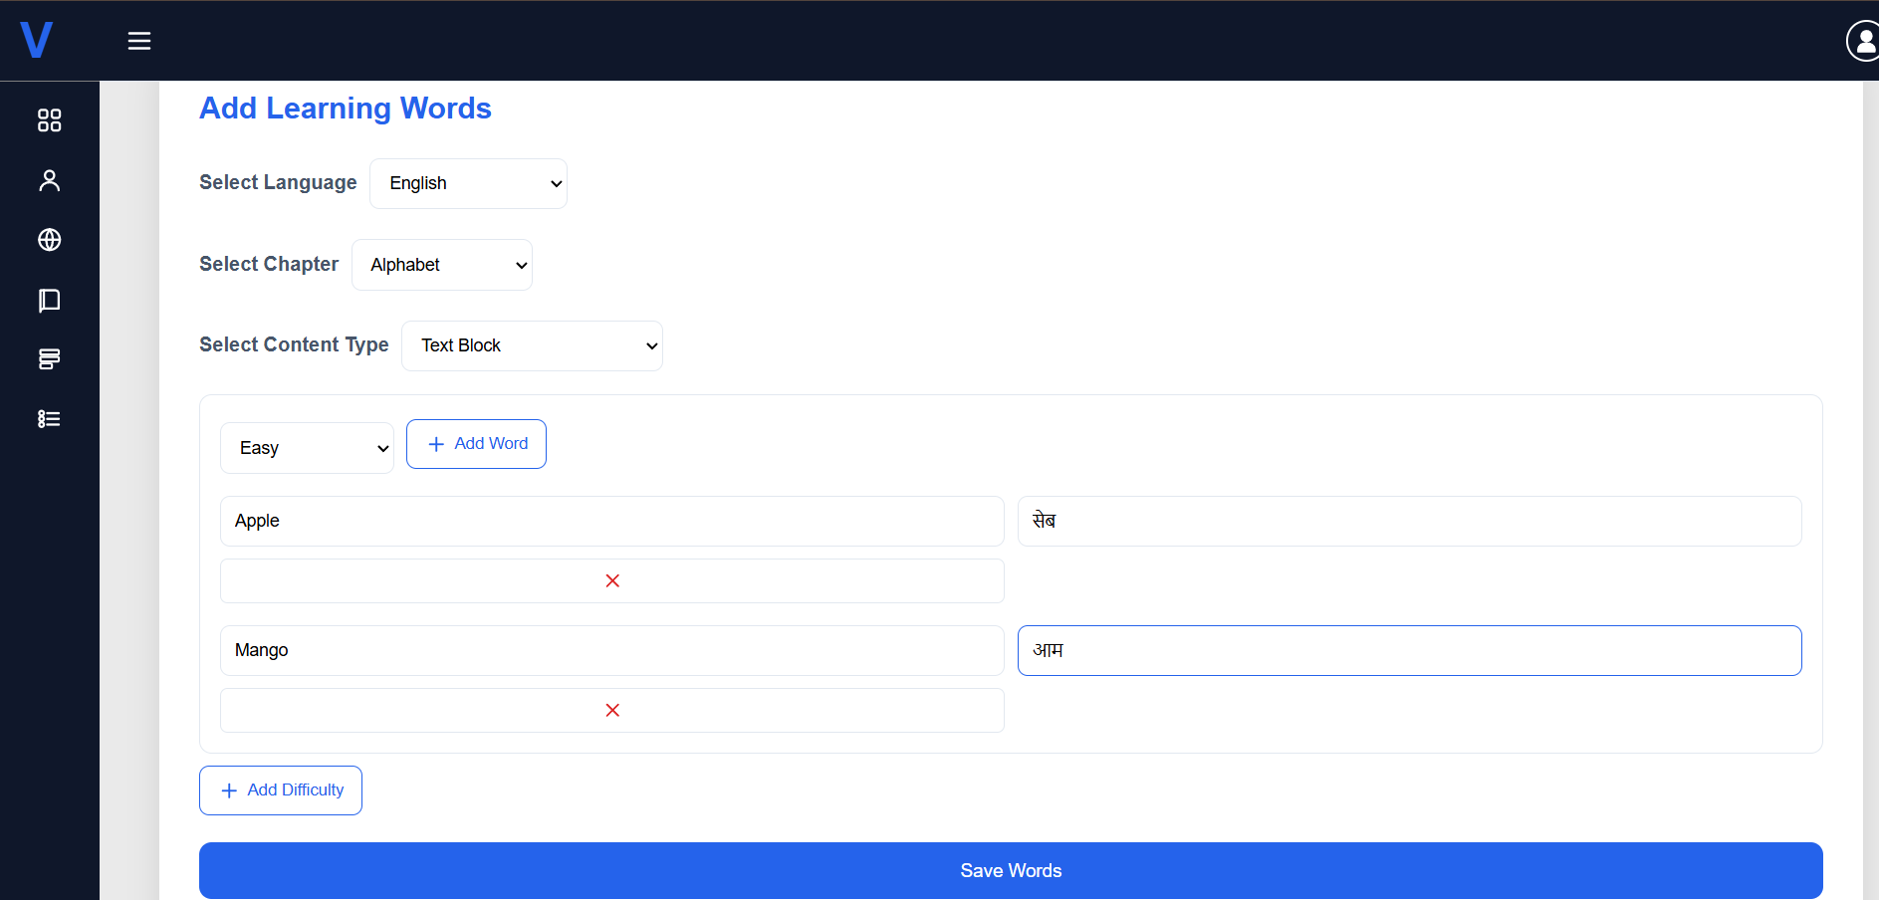
if admin select the Content Type = TextArea
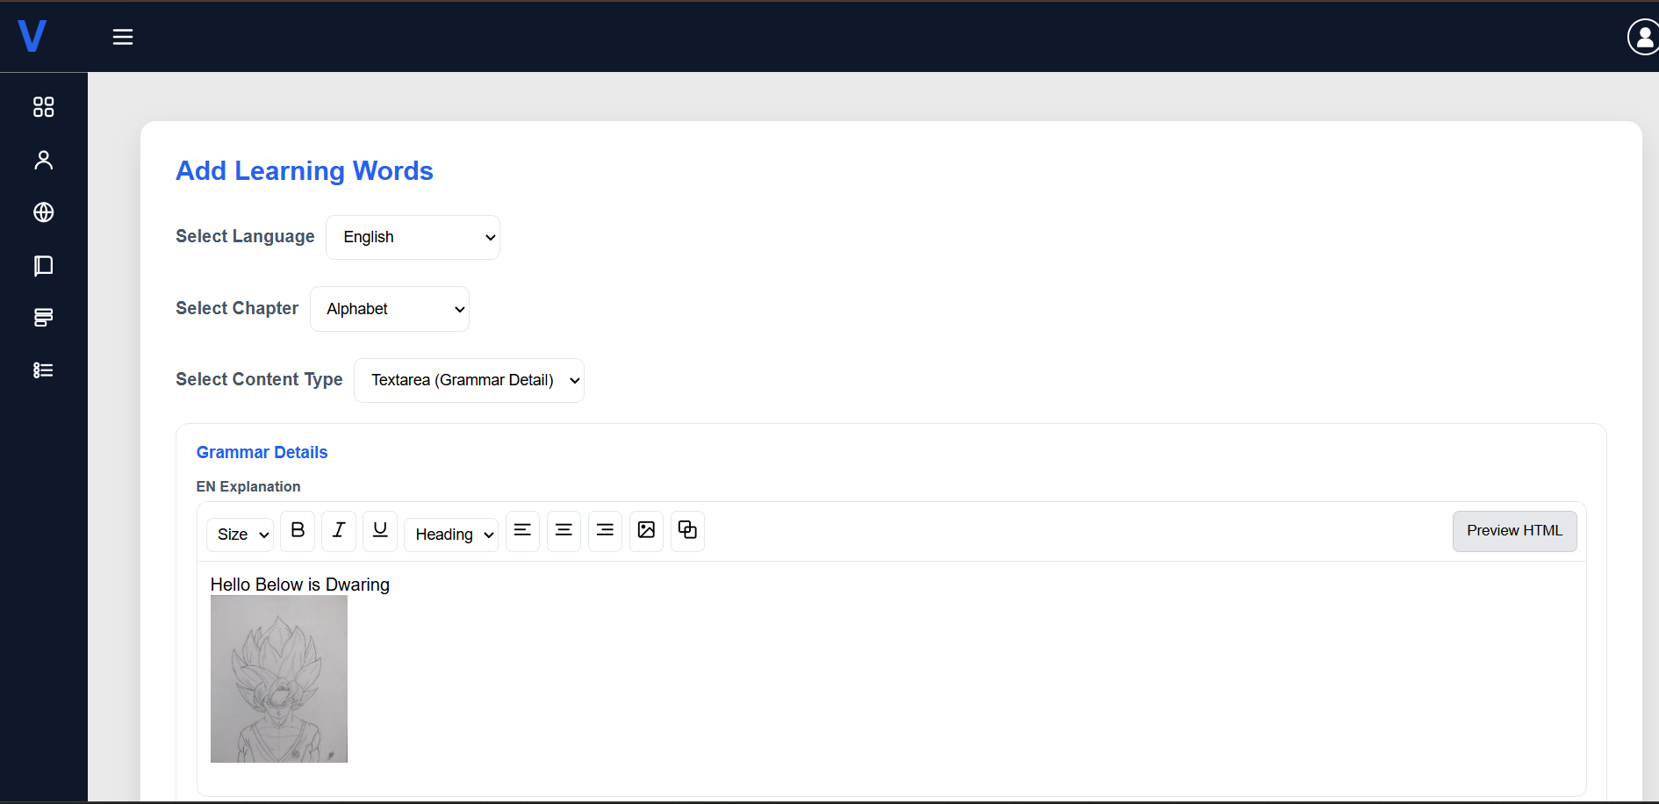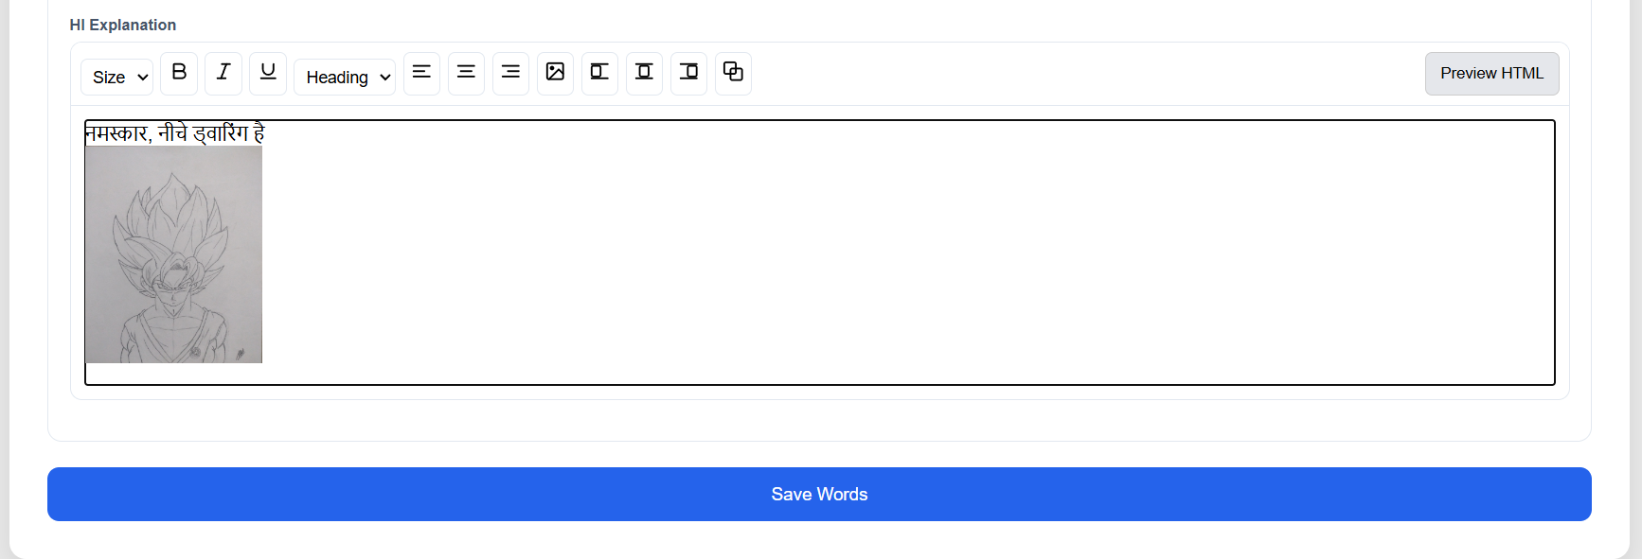

- Add MCQs Page
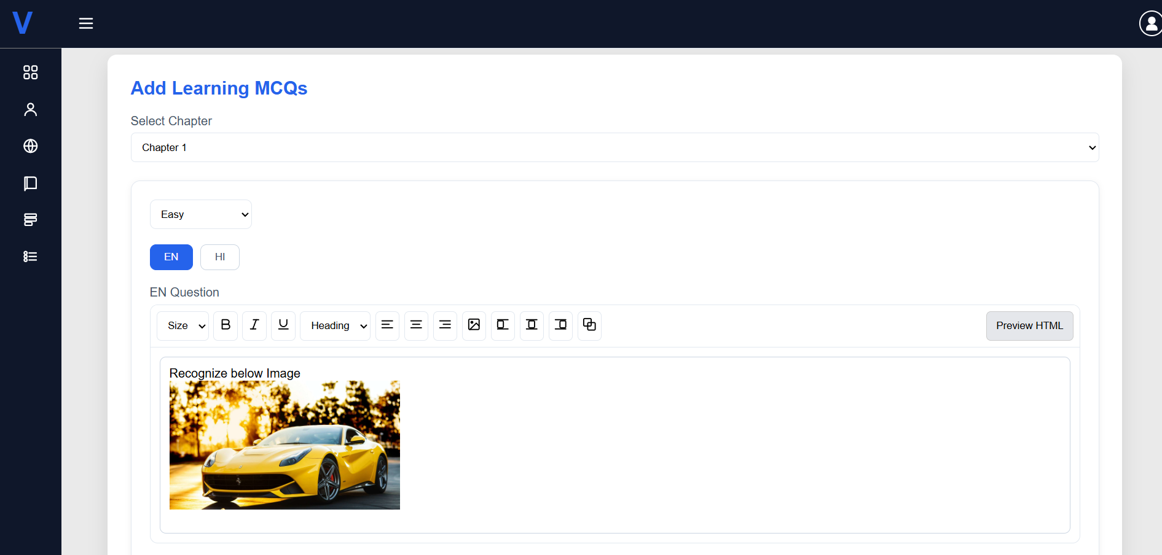
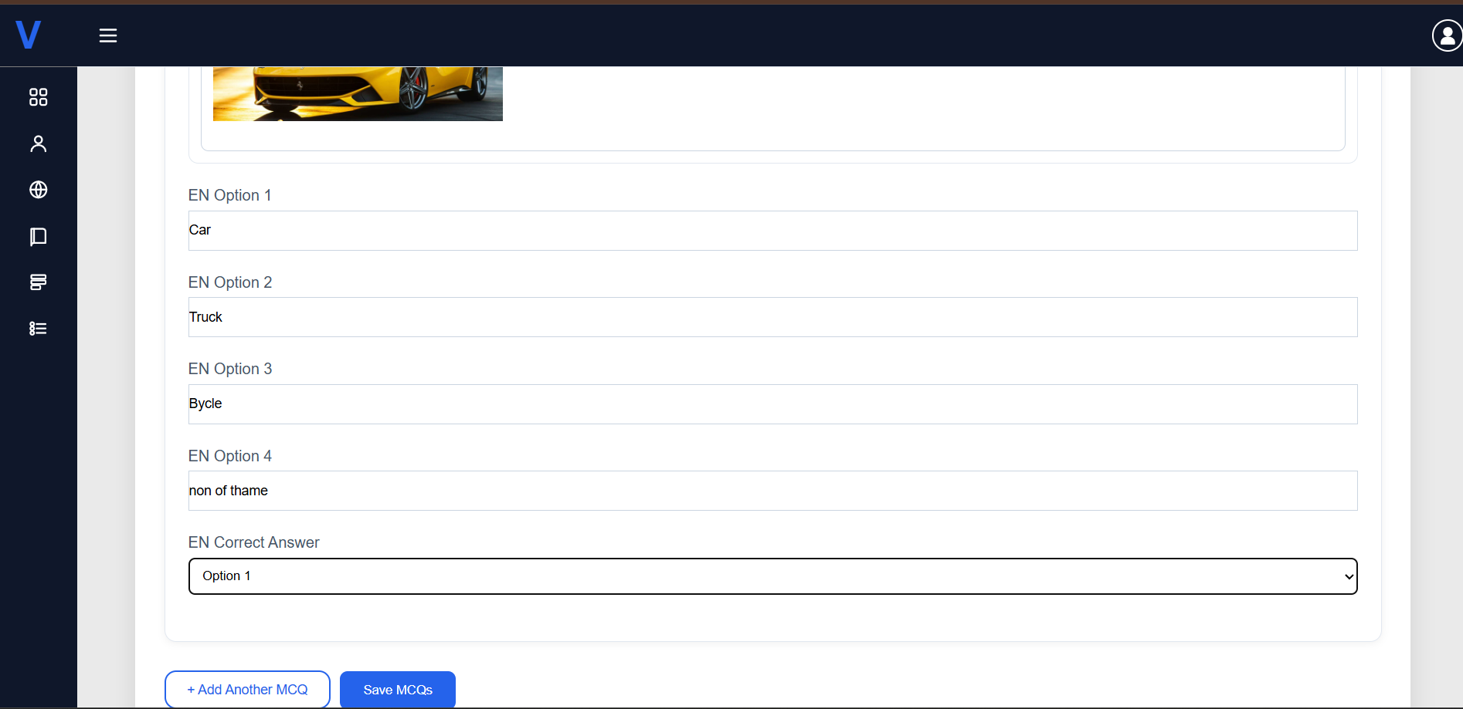

5. Agile Documentation.

5.1 Agile Project Charter: -

General Project Information
Project Name | Voco - Native Language Learning Platform
Project Champion | Meet Patel, Yash Shah, Krishna Radhani
Project Sponsor | -
Project Manager | Prof Harsh Shah
Stakeholders | -
Expected Start Date | 29/12/2025
Expected Completion Date | 22/04/2026

Project Details
Mission | To provide an interactive and accessible digital platform that enables users to learn new languages efficiently through structured lessons, real-time assessments, and practical learning tools. VOCO aims to simplify language acquisition using technology-driven features such as multilingual support, progress tracking, and personalized learning experiences.
Vision | To become a leading global language learning platform that empowers individuals to communicate across cultures by leveraging modern web technologies, intelligent learning systems, and user-centric design. VOCO envisions a future where language barriers are eliminated through seamless and engaging digital education.
Scope | The VOCO platform is designed to provide a comprehensive and scalable solution for language learning by integrating modern web technologies with structured educational content. It includes features such as user registration and secure authentication using OTP and JWT, enabling personalized access for each user. The system supports multi-language learning with modules covering vocabulary, grammar, and pronunciation, enhanced by text-to-speech functionality for better understanding. Users can progress through chapter-wise content, attempt MCQ-based assessments, and track their learning progress in real time. Additionally, the platform offers a final exam system and generates verified certificates with QR-based validation upon successful completion. An integrated admin panel allows efficient management of users, languages, learning content, and questions. Technically, the system is built using the MERN stack with RESTful APIs, multilingual UI support, and integration of external services such as email and SMS. The scope of VOCO can be further extended in the future to include AI-based personalized learning, voice recognition, mobile applications, and gamification features, making it a robust and future-ready language learning solution.

5.2 Agile Roadmap/Schedule: -
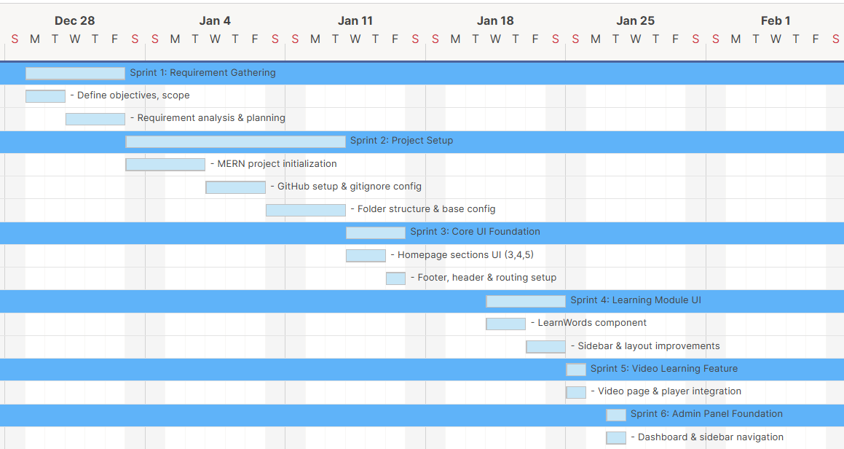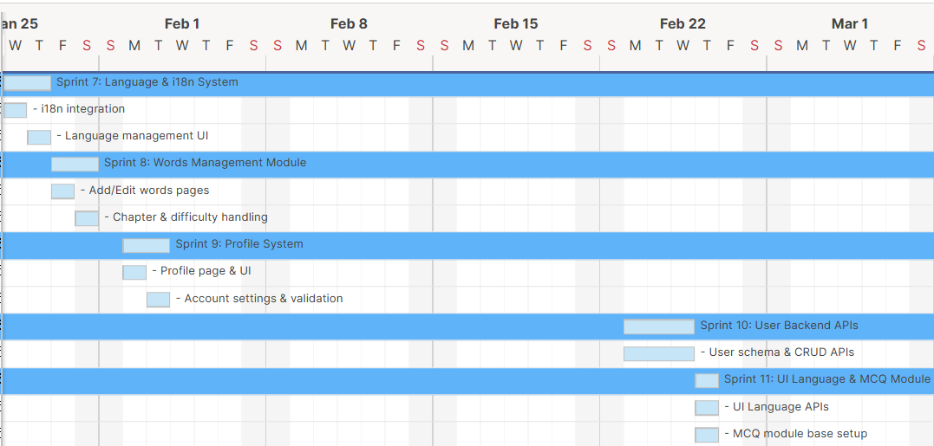

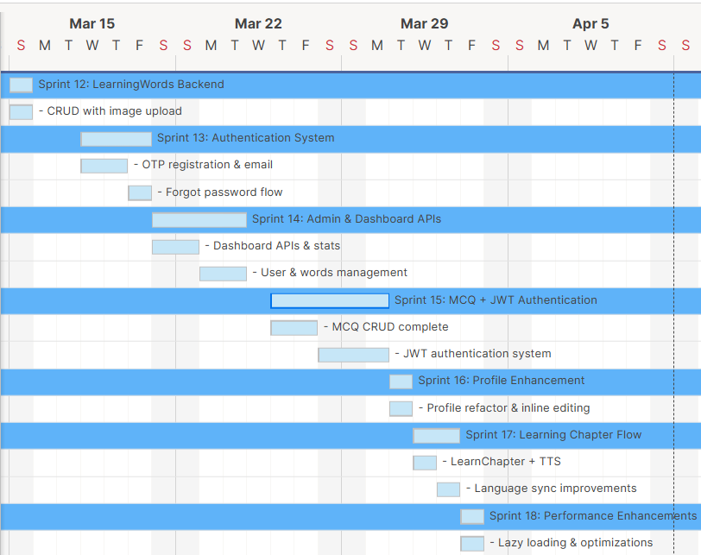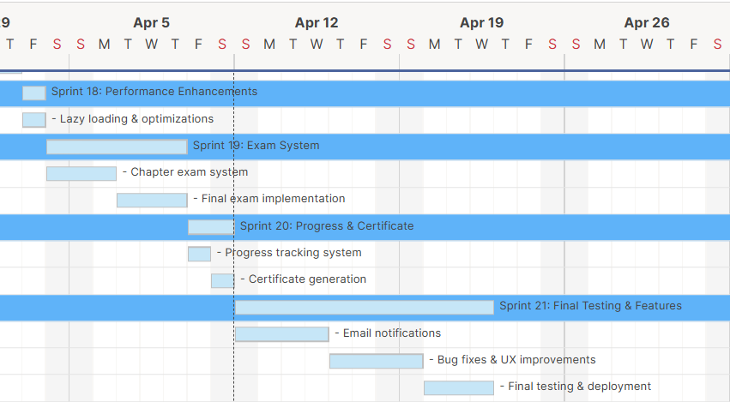

5.3 Agile Project Plan: -
Task Name | Duration | Start | Finish | Status
Sprint 1: Requirement Gathering | 5d | 29-12-2025 | 02-01-2026 | Complete
- Define objectives, scope | 2d | 29-12-2025 | 30-12-2025 | Complete
- Requirement analysis & planning | 3d | 31-12-2025 | 02-01-2026 | Complete
Sprint 2: Project Setup | 10d | 03-01-2026 | 13-01-2026 | Complete
- MERN project initialization | 4d | 03-01-2026 | 06-01-2026 | Complete
- GitHub setup & gitignore config | 3d | 07-01-2026 | 09-01-2026 | Complete
- Folder structure & base config | 3d | 10-01-2026 | 13-01-2026 | Complete
Sprint 3: Core UI Foundation | 3d | 14-01-2026 | 16-01-2026 | Complete
- Homepage sections UI (3,4,5) | 2d | 14-01-2026 | 15-01-2026 | Complete
- Footer, header & routing setup | 1d | 16-01-2026 | 16-01-2026 | Complete
Sprint 4: Learning Module UI | 4d | 21-01-2026 | 24-01-2026 | Complete
- LearnWords component | 2d | 21-01-2026 | 22-01-2026 | Complete
- Sidebar & layout improvements | 2d | 23-01-2026 | 24-01-2026 | Complete
Sprint 5: Video Learning Feature | 1d | 25-01-2026 | 25-01-2026 | Complete
- Video page & player integration | 1d | 25-01-2026 | 25-01-2026 | Complete
Sprint 6: Admin Panel Foundation | 1d | 27-01-2026 | 27-01-2026 | Complete
- Dashboard & sidebar navigation | 1d | 27-01-2026 | 27-01-2026 | Complete
Sprint 7: Language & i18n System | 2d | 28-01-2026 | 29-01-2026 | Complete
- i18n integration | 1d | 28-01-2026 | 28-01-2026 | Complete
- Language management UI | 1d | 29-01-2026 | 29-01-2026 | Complete
Sprint 8: Words Management Module | 2d | 30-01-2026 | 31-01-2026 | Complete
- Add/Edit words pages | 1d | 30-01-2026 | 30-01-2026 | Complete
- Chapter & difficulty handling | 1d | 31-01-2026 | 31-01-2026 | Complete
Sprint 9: Profile System | 2d | 02-02-2026 | 03-02-2026 | Complete
- Profile page & UI | 1d | 02-02-2026 | 02-02-2026 | Complete
- Account settings & validation | 1d | 03-02-2026 | 03-02-2026 | Complete
Sprint 10: User Backend APIs | 3d | 23-02-2026 | 25-02-2026 | Complete
- User schema & CRUD APIs | 3d | 23-02-2026 | 25-02-2026 | Complete
Sprint 11: UI Language & MCQ Module | 1d | 26-02-2026 | 26-02-2026 | Complete
- UI Language APIs | 1d | 26-02-2026 | 26-02-2026 | Complete
- MCQ module base setup | 1d | 26-02-2026 | 26-02-2026 | Complete
Sprint 12: LearningWords Backend | 1d | 15-03-2026 | 15-03-2026 | Complete
- CRUD with image upload | 1d | 15-03-2026 | 15-03-2026 | Complete
Sprint 13: Authentication System | 3d | 18-03-2026 | 20-03-2026 | Complete
- OTP registration & email | 2d | 18-03-2026 | 19-03-2026 | Complete
- Forgot password flow | 1d | 20-03-2026 | 20-03-2026 | Complete
Sprint 14: Admin & Dashboard APIs | 4d | 21-03-2026 | 24-03-2026 | Complete
- Dashboard APIs & stats | 2d | 21-03-2026 | 22-03-2026 | Complete
- User & words management | 2d | 23-03-2026 | 24-03-2026 | Complete
Sprint 15: MCQ + JWT Authentication | 5d | 26-03-2026 | 30-03-2026 | Complete
- MCQ CRUD complete | 2d | 26-03-2026 | 27-03-2026 | Complete
- JWT authentication system | 3d | 28-03-2026 | 30-03-2026 | Complete
Sprint 16: Profile Enhancement | 1d | 31-03-2026 | 31-03-2026 | Complete
- Profile refactor & inline editing | 1d | 31-03-2026 | 31-03-2026 | Complete
Sprint 17: Learning Chapter Flow | 2d | 01-04-2026 | 02-04-2026 | Complete
- LearnChapter + TTS | 1d | 01-04-2026 | 01-04-2026 | Complete
- Language sync improvements | 1d | 02-04-2026 | 02-04-2026 | Complete
Sprint 18: Performance Enhancements | 1d | 03-04-2026 | 03-04-2026 | Complete
- Lazy loading & optimizations | 1d | 03-04-2026 | 03-04-2026 | Complete
Sprint 19: Exam System | 6d | 04-04-2026 | 09-04-2026 | Complete
- Chapter exam system | 3d | 04-04-2026 | 06-04-2026 | Complete
- Final exam implementation | 3d | 07-04-2026 | 09-04-2026 | Complete
Sprint 20: Progress & Certificate | 2d | 10-04-2026 | 11-04-2026 | Complete
- Progress tracking system | 1d | 10-04-2026 | 10-04-2026 | Complete
- Certificate generation | 1d | 11-04-2026 | 11-04-2026 | Complete
Sprint 21: Final Testing & Features | 11d | 12-04-2026 | 22-04-2026 | Complete
- Email notifications | 4d | 12-04-2026 | 15-04-2026 | Complete
- Bug fixes & UX improvements | 4d | 16-04-2026 | 19-04-2026 | Complete
- Final testing & deployment | 3d | 20-04-2026 | 22-04-2026 | Complete

5.4 Agile User Story: -

Story-1(Admin)
User Story Id | As a <User> | Want To <Task> | So that <Goal>
1 | Admin | Login | I can access the admin dashboard and manage the system.
2 | Admin | Manage Users | I can add, update, block, or delete users in the system.
3 | Admin | Manage User Roles | I can assign roles and permissions to users.
4 | Admin | Manage Learning Languages | I can create, update, and delete learning languages and chapters.
5 | Admin | Manage UI Languages | I can control supported interface languages for users.
6 | Admin | Manage Learning Words | I can add, edit, and delete vocabulary and grammar content.
7 | Admin | Manage MCQs | I can create, update, and delete questions for exams.
8 | Admin | View Dashboard | I can monitor system stats like users, languages, and activity.
12 | Admin | Logout | I can securely exit the system and protect data.

Story-2(User)
User Story Id | As a <User> | Want To <Task> | So that <Goal>
1 | User | Register | I can create an account and access the platform.
2 | User | Login | I can securely access my account and continue learning.
3 | User | Verify OTP | I can confirm my identity during registration or password reset.
4 | User | Select Learning Language | I can choose the language I want to learn.
5 | User | Learn Words & Grammar | I can improve my vocabulary and language understanding.
6 | User | Listen to Pronunciation | I can learn correct pronunciation using text-to-speech.
7 | User | Attempt Chapter Exams | I can test my knowledge after completing a chapter.
8 | User | Track Progress | I can see my learning progress and completed chapters.
9 | User | Attempt Final Exam | I can evaluate my overall knowledge of the language.
10 | User | Get Certificate | I can receive a certificate after successfully completing the course.
11 | User | Update Profile | I can edit my personal details and preferences.
12 | User | Reset Password | I can recover access if I forget my password.
13 | User | Receive Notifications | I can get updates about exams and results via email/SMS.
14 | User | Logout | I can securely exit my account.

5.5 Agile Release Plan: -
Task Name | Duration | Start | Finish | Status | Release Date
Sprint 1: Requirement Gathering | 5d | 29-12-2025 | 02-01-2026 | Complete | 02-01-2026
- Define objectives, scope | 2d | 29-12-2025 | 30-12-2025 | Complete | 30-12-2025
- Requirement analysis & planning | 3d | 31-12-2025 | 02-01-2026 | Complete | 02-01-2026
Sprint 2: Project Setup | 10d | 03-01-2026 | 13-01-2026 | Complete | 13-01-2026
- MERN project initialization | 4d | 03-01-2026 | 06-01-2026 | Complete | 06-01-2026
- GitHub setup & gitignore config | 3d | 07-01-2026 | 09-01-2026 | Complete | 09-01-2026
- Folder structure & base config | 3d | 10-01-2026 | 13-01-2026 | Complete | 13-01-2026
Sprint 3: Core UI Foundation | 3d | 14-01-2026 | 16-01-2026 | Complete | 16-01-2026
- Homepage sections UI (3,4,5) | 2d | 14-01-2026 | 15-01-2026 | Complete | 15-01-2026
- Footer, header & routing setup | 1d | 16-01-2026 | 16-01-2026 | Complete | 16-01-2026
Sprint 4: Learning Module UI | 4d | 21-01-2026 | 24-01-2026 | Complete | 24-01-2026
- LearnWords component | 2d | 21-01-2026 | 22-01-2026 | Complete | 22-01-2026
- Sidebar & layout improvements | 2d | 23-01-2026 | 24-01-2026 | Complete | 24-01-2026
Sprint 5: Video Learning Feature | 1d | 25-01-2026 | 25-01-2026 | Complete | 25-01-2026
- Video page & player integration | 1d | 25-01-2026 | 25-01-2026 | Complete | 25-01-2026
Sprint 6: Admin Panel Foundation | 1d | 27-01-2026 | 27-01-2026 | Complete | 27-01-2026
- Dashboard & sidebar navigation | 1d | 27-01-2026 | 27-01-2026 | Complete | 27-01-2026
Sprint 7: Language & i18n System | 2d | 28-01-2026 | 29-01-2026 | Complete | 29-01-2026
- i18n integration | 1d | 28-01-2026 | 28-01-2026 | Complete | 28-01-2026
- Language management UI | 1d | 29-01-2026 | 29-01-2026 | Complete | 29-01-2026
Sprint 8: Words Management Module | 2d | 30-01-2026 | 31-01-2026 | Complete | 31-01-2026
- Add/Edit words pages | 1d | 30-01-2026 | 30-01-2026 | Complete | 30-01-2026
- Chapter & difficulty handling | 1d | 31-01-2026 | 31-01-2026 | Complete | 31-01-2026
Sprint 9: Profile System | 2d | 02-02-2026 | 03-02-2026 | Complete | 03-02-2026
- Profile page & UI | 1d | 02-02-2026 | 02-02-2026 | Complete | 02-02-2026
- Account settings & validation | 1d | 03-02-2026 | 03-02-2026 | Complete | 03-02-2026
Sprint 10: User Backend APIs | 3d | 23-02-2026 | 25-02-2026 | Complete | 25-02-2026
- User schema & CRUD APIs | 3d | 23-02-2026 | 25-02-2026 | Complete | 25-02-2026
Sprint 11: UI Language & MCQ Module | 1d | 26-02-2026 | 26-02-2026 | Complete | 26-02-2026
- UI Language APIs | 1d | 26-02-2026 | 26-02-2026 | Complete | 26-02-2026
- MCQ module base setup | 1d | 26-02-2026 | 26-02-2026 | Complete | 26-02-2026
Sprint 12: LearningWords Backend | 1d | 15-03-2026 | 15-03-2026 | Complete | 15-03-2026
- CRUD with image upload | 1d | 15-03-2026 | 15-03-2026 | Complete | 15-03-2026
Sprint 13: Authentication System | 3d | 18-03-2026 | 20-03-2026 | Complete | 20-03-2026
- OTP registration & email | 2d | 18-03-2026 | 19-03-2026 | Complete | 19-03-2026
- Forgot password flow | 1d | 20-03-2026 | 20-03-2026 | Complete | 20-03-2026
Sprint 14: Admin & Dashboard APIs | 4d | 21-03-2026 | 24-03-2026 | Complete | 24-03-2026
- Dashboard APIs & stats | 2d | 21-03-2026 | 22-03-2026 | Complete | 22-03-2026
- User & words management | 2d | 23-03-2026 | 24-03-2026 | Complete | 24-03-2026
Sprint 15: MCQ + JWT Authentication | 5d | 26-03-2026 | 30-03-2026 | Complete | 30-03-2026
- MCQ CRUD complete | 2d | 26-03-2026 | 27-03-2026 | Complete | 27-03-2026
- JWT authentication system | 3d | 28-03-2026 | 30-03-2026 | Complete | 30-03-2026
Sprint 16: Profile Enhancement | 1d | 31-03-2026 | 31-03-2026 | Complete | 31-03-2026
- Profile refactor & inline editing | 1d | 31-03-2026 | 31-03-2026 | Complete | 31-03-2026
Sprint 17: Learning Chapter Flow | 2d | 01-04-2026 | 02-04-2026 | Complete | 02-04-2026
- LearnChapter + TTS | 1d | 01-04-2026 | 01-04-2026 | Complete | 01-04-2026
- Language sync improvements | 1d | 02-04-2026 | 02-04-2026 | Complete | 02-04-2026
Sprint 18: Performance Enhancements | 1d | 03-04-2026 | 03-04-2026 | Complete | 03-04-2026
- Lazy loading & optimizations | 1d | 03-04-2026 | 03-04-2026 | Complete | 03-04-2026
Sprint 19: Exam System | 6d | 04-04-2026 | 09-04-2026 | Complete | 09-04-2026
- Chapter exam system | 3d | 04-04-2026 | 06-04-2026 | Complete | 06-04-2026
- Final exam implementation | 3d | 07-04-2026 | 09-04-2026 | Complete | 09-04-2026
Sprint 20: Progress & Certificate | 2d | 10-04-2026 | 11-04-2026 | Complete | 11-04-2026
- Progress tracking system | 1d | 10-04-2026 | 10-04-2026 | Complete | 10-04-2026
- Certificate generation | 1d | 11-04-2026 | 11-04-2026 | Complete | 11-04-2026
Sprint 21: Final Testing & Features | 11d | 12-04-2026 | 22-04-2026 | Complete | 22-04-2026
- Email notifications | 4d | 12-04-2026 | 15-04-2026 | Complete | 15-04-2026
- Bug fixes & UX improvements | 4d | 16-04-2026 | 19-04-2026 | Complete | 19-04-2026
- Final testing & deployment | 3d | 20-04-2026 | 22-04-2026 | Complete | 22-04-2026

5.6 Agile Sprint Backlogs: -
Task Name | Duration | Start | Finish | Priority | Status
Sprint 1: Requirement Gathering | 5d | 29-12-2025 | 02-01-2026 | High | Complete
- Define objectives, scope | 2d | 29-12-2025 | 30-12-2025 | High | Complete
- Requirement analysis & planning | 3d | 31-12-2025 | 02-01-2026 | High | Complete
Sprint 2: Project Setup | 10d | 03-01-2026 | 13-01-2026 | High | Complete
- MERN project initialization | 4d | 03-01-2026 | 06-01-2026 | High | Complete
- GitHub setup & gitignore config | 3d | 07-01-2026 | 09-01-2026 | High | Complete
- Folder structure & base config | 3d | 10-01-2026 | 13-01-2026 | High | Complete
Sprint 3: Core UI Foundation | 3d | 14-01-2026 | 16-01-2026 | Medium | Complete
- Homepage sections UI (3,4,5) | 2d | 14-01-2026 | 15-01-2026 | Medium | Complete
- Footer, header & routing setup | 1d | 16-01-2026 | 16-01-2026 | Medium | Complete
Sprint 4: Learning Module UI | 4d | 21-01-2026 | 24-01-2026 | Medium | Complete
- LearnWords component | 2d | 21-01-2026 | 22-01-2026 | Medium | Complete
- Sidebar & layout improvements | 2d | 23-01-2026 | 24-01-2026 | Medium | Complete
Sprint 5: Video Learning Feature | 1d | 25-01-2026 | 25-01-2026 | Low | Complete
- Video page & player integration | 1d | 25-01-2026 | 25-01-2026 | Low | Complete
Sprint 6: Admin Panel Foundation | 1d | 27-01-2026 | 27-01-2026 | High | Complete
- Dashboard & sidebar navigation | 1d | 27-01-2026 | 27-01-2026 | High | Complete
Sprint 7: Language & i18n System | 2d | 28-01-2026 | 29-01-2026 | High | Complete
- i18n integration | 1d | 28-01-2026 | 28-01-2026 | High | Complete
- Language management UI | 1d | 29-01-2026 | 29-01-2026 | High | Complete
Sprint 8: Words Management Module | 2d | 30-01-2026 | 31-01-2026 | High | Complete
- Add/Edit words pages | 1d | 30-01-2026 | 30-01-2026 | High | Complete
- Chapter & difficulty handling | 1d | 31-01-2026 | 31-01-2026 | High | Complete
Sprint 9: Profile System | 2d | 02-02-2026 | 03-02-2026 | Medium | Complete
- Profile page & UI | 1d | 02-02-2026 | 02-02-2026 | Medium | Complete
- Account settings & validation | 1d | 03-02-2026 | 03-02-2026 | Medium | Complete
Sprint 10: User Backend APIs | 3d | 23-02-2026 | 25-02-2026 | High | Complete
- User schema & CRUD APIs | 3d | 23-02-2026 | 25-02-2026 | High | Complete
Sprint 11: UI Language & MCQ Module | 1d | 26-02-2026 | 26-02-2026 | High | Complete
- UI Language APIs | 1d | 26-02-2026 | 26-02-2026 | High | Complete
- MCQ module base setup | 1d | 26-02-2026 | 26-02-2026 | High | Complete
Sprint 12: LearningWords Backend | 1d | 15-03-2026 | 15-03-2026 | High | Complete
- CRUD with image upload | 1d | 15-03-2026 | 15-03-2026 | High | Complete
Sprint 13: Authentication System | 3d | 18-03-2026 | 20-03-2026 | High | Complete
- OTP registration & email | 2d | 18-03-2026 | 19-03-2026 | High | Complete
- Forgot password flow | 1d | 20-03-2026 | 20-03-2026 | High | Complete
Sprint 14: Admin & Dashboard APIs | 4d | 21-03-2026 | 24-03-2026 | High | Complete
- Dashboard APIs & stats | 2d | 21-03-2026 | 22-03-2026 | High | Complete
- User & words management | 2d | 23-03-2026 | 24-03-2026 | High | Complete
Sprint 15: MCQ + JWT Authentication | 5d | 26-03-2026 | 30-03-2026 | High | Complete
- MCQ CRUD complete | 2d | 26-03-2026 | 27-03-2026 | High | Complete
- JWT authentication system | 3d | 28-03-2026 | 30-03-2026 | High | Complete
Sprint 16: Profile Enhancement | 1d | 31-03-2026 | 31-03-2026 | Medium | Complete
- Profile refactor & inline editing | 1d | 31-03-2026 | 31-03-2026 | Medium | Complete
Sprint 17: Learning Chapter Flow | 2d | 01-04-2026 | 02-04-2026 | High | Complete
- LearnChapter + TTS | 1d | 01-04-2026 | 01-04-2026 | High | Complete
- Language sync improvements | 1d | 02-04-2026 | 02-04-2026 | High | Complete
Sprint 18: Performance Enhancements | 1d | 03-04-2026 | 03-04-2026 | Low | Complete
- Lazy loading & optimizations | 1d | 03-04-2026 | 03-04-2026 | Low | Complete
Sprint 19: Exam System | 6d | 04-04-2026 | 09-04-2026 | High | Complete
- Chapter exam system | 3d | 04-04-2026 | 06-04-2026 | High | Complete
- Final exam implementation | 3d | 07-04-2026 | 09-04-2026 | High | Complete
Sprint 20: Progress & Certificate | 2d | 10-04-2026 | 11-04-2026 | High | Complete
- Progress tracking system | 1d | 10-04-2026 | 10-04-2026 | High | Complete
- Certificate generation | 1d | 11-04-2026 | 11-04-2026 | High | Complete
Sprint 21: Final Testing & Features | 11d | 12-04-2026 | 22-04-2026 | High | Complete
- Email notifications | 4d | 12-04-2026 | 15-04-2026 | High | Complete
- Bug fixes & UX improvements | 4d | 16-04-2026 | 19-04-2026 | High | Complete
- Final testing & deployment | 3d | 20-04-2026 | 22-04-2026 | High | Complete

5.7 Agile Test Plan: -

Test Case ID | 101 | Test Case Name | User Registration
Project Name | VOCO - Native Language Learning Platform | Browser | Google Chrome
Written By | Yash Shah | Description | User registration page where new users create an account using email, password, and OTP verification.
Tested By | Meet Patel | Tested On | 18-03-2026
Test # | Test Data | Expected Result | Actual Result | Status
1 | Valid email, password, username | User successfully registered | User successfully registered | Pass
2 | Duplicate email | Error: "User already exists" | Error displayed correctly | Pass
3 | Weak password (<8 chars) | Error: "Password must be strong" | Error displayed | Pass
4 | Invalid email format | Error: "Invalid email" | Error displayed | Pass
5 | Valid data but OTP not entered | Registration blocked | User blocked | Pass
6 | Duplicate phone/email | Registration fails | User registered | Fail

Test Case ID | 102 | Test Case Name | User Login
Project Name | VOCO - Native Language Learning Platform | Browser | Google Chrome
Written By | Meet Patel | Description | User login using email and password with JWT authentication.
Tested By | Krishna Radhani | Tested On | 20-03-2026
Test # | Test Data | Expected Result | Actual Result | Status
1 | Valid email & password | Login successful | Login successful | Pass
2 | Wrong password | Error: "Invalid credentials" | Error shown | Pass
3 | Non-existing email | Error: "User not found" | Error shown | Pass
4 | Empty fields | Validation error | Validation error | Pass
5 | Token expired | Auto logout | logged out | Pass

Test Case ID | 103 | Test Case Name | Learning Words Module
Project Name | VOCO - Native Language Learning Platform | Browser | Google Chrome
Written By | Krishna Radhani | Description | User can view, and Admin can add, and interact with learning words.
Tested By | Yash Shah | Tested On | 15-03-2026
Test # | Test Step | Action | Expected Result | Actual Result | Status
1 | Open LearnWords page | Click module | Words displayed | Words displayed | Pass
2 | Select language | Choose language | Filtered words shown | Works correctly | Pass
3 | Play pronunciation | Click speaker icon | Audio plays | Audio plays | Pass
4 | Invalid word data | Load page | Handle error | Page crashes | Fail

Test Case ID | 104 | Test Case Name | MCQ Module
Project Name | VOCO - Native Language Learning Platform | Browser | Google Chrome
Written By | Meet Patel | Description | Admin can add/edit MCQs and users can attempt them.
Tested By | Yash Shah | Tested On | 26-03-2026
Test # | Test Step | Action | Expected Result | Actual Result | Status
1 | Add MCQ | Fill valid data | MCQ added | MCQ added | Pass
2 | Edit MCQ | Update question | MCQ updated | MCQ updated | Pass
3 | Delete MCQ | Remove MCQ | Deleted | Deleted | Pass
4 | Invalid input | Submit empty fields | Error shown | Error shown | Pass

Test Case ID | 105 | Test Case Name | Chapter Exam
Project Name | VOCO - Native Language Learning Platform | Browser | Google Chrome
Written By | Yash Shah | Description | User attempts chapter-wise MCQ exam.
Tested By | Meet Patel | Tested On | 05-04-2026
Test # | Test Step | Action | Expected Result | Actual Result | Status
1 | Add MCQ | Fill valid data | MCQ added | MCQ added | Pass
2 | Edit MCQ | Update question | MCQ updated | MCQ updated | Pass
3 | Delete MCQ | Remove MCQ | Deleted | Deleted | Pass
4 | Invalid input | Submit empty fields | Error shown | No shown | Pass

Test Case ID | 106 | Test Case Name | Final Exam
Project Name | VOCO - Native Language Learning Platform | Browser | Google Chrome
Written By | Meet Patel | Description | User attempts final exam after completing all chapters.
Tested By | Krishna Radhani | Tested On | 09-04-2026
Test # | Test Step | Action | Expected Result | Actual Result | Status
1 | Start final exam | Click start | Exam opens | Opens | Pass
2 | Without completing chapters | Access exam | Access denied | Allowed | Fail
3 | Submit exam | Complete exam | Score generated | Generated | Pass

6. Proposed Enhancement.

- Implement AI-based personalized learning recommendations.
- Add voice recognition for pronunciation evaluation.
- Introduce gamification features like badges, points, and leaderboards.
- Enhance admin dashboard with advanced analytics and reports.
- Add social learning features such as discussion forums and group learning.
- Provide offline learning mode for accessing content without internet.
- Enable multi-device synchronization of user progress.
- Improve security with features like two-factor authentication (2FA).
- Integrate third-party APIs for translation, speech, and verification.

7. Conclusion.

The VOCO platform is a modern language learning system developed using the MERN stack, designed to provide an interactive and user-friendly environment for learners. It offers key features such as secure authentication, multi-language learning modules, chapter-wise and final examinations, progress tracking, and certificate generation. The system ensures a smooth and scalable user experience through efficient frontend and backend integration.
The project follows Agile methodology, enabling incremental development, continuous improvement, and better feature management across multiple sprints. This approach helped in building a robust system with well-structured modules like user management, admin controls, and assessment systems.
Overall, VOCO provides an effective digital solution for language learning, combining technology with structured content delivery. The platform also has strong potential for future enhancements such as AI-based personalized learning, voice recognition, and mobile application support, making it a scalable and future-ready system.

8. Bibliography.

- MongoDB Documentation.
Available at: https://www.mongodb.com/docs/
- Express.js Official Documentation.
Available at: https://expressjs.com/
- React Official Documentation.
Available at: https://react.dev/
- Node.js Documentation.
Available at: https://nodejs.org/en/docs/
- JWT Introduction and Documentation.
Available at: https://jwt.io/introduction
- i18next Documentation.
Available at: https://www.i18next.com/
- Nodemailer Documentation.
Available at: https://nodemailer.com/about/
- Twilio Documentation.
Available at: https://www.twilio.com/docs
- GitHub.
Available at: https://github.com/

